IMMUNE AGING IN LONG-LIVED AND SHORT-LIVED POPULATIONS OF

*DROSOPHILA MELANOGASTER*

____________________________________

A Thesis

Presented to the

Faculty of

California State University, Fullerton

____________________________________

In Partial Fulfillment

of the Requirements for the Degree

Master of Science

in

Biological Sciences

____________________________________

By

Elnaz Bagheri

Thesis Committee Approval:

Parvin Shahrestani, Department of Biological Sciences

Nilay Patel, Department of Biological Sciences

Catherine Brennan, Department of Biological Sciences

Spring, 2020

Abstract

Lifespan is highly variable across species, across populations, and among individuals of the same population. Mortality rates, which affect lifespan, vary across age classes and may in part be influenced by bacteria, viruses, and fungi that create infectious diseases. This study explores three questions about the relationship between longevity and infection resistance, using the laboratory fruit fly *Drosophila melanogaster*. First, what is the relationship between longevity and immune defense in short-lived and long-lived *D. melanogaster*populations? Second, what is the effect of chronological age on immune defense in short and long lived populations? Third, does experimental evolution for longevity differentiation disproportionately affect immune defense genes?

Short and long-lived *D. melanogaster* populations were compared for differences in survival post-infection with the fungal pathogen *Beauveria bassiana*. This character was measured at multiple ages throughout the lifespan. Post-infection survival was lower in short-lived populations at all chronological ages compared to the same ages in long-lived populations, and post-infection survival declined with age in both short-lived and long-lived populations. Whole-genome differentiation among the short- and long- lived populations was briefly explored for enrichment of immune defense genes.

Results from this study can potentially inform the use of *B. bassiana*in biological control against mosquito vectors of human disease, because of the similarities between mosquito and *D. melanogaster* immune defenses. Moreover, due to homology between the innate immunities of fruit flies and humans, results from this study can inform the need for personalized medicine, such as treating old and young patients differently after infection.

TABLE OF CONTENTS

ABSTRACT ii

LIST OF TABLES v

LIST OF FIGURES vi

ACKNOWLEDGMENTS viii

Chapter

1. INTRODUCTION 1

2. METHODS 10

*Drosophila melanogaster* Populations 10

Fungal Spray 12

Mortality 14

Statistical Analysis 14

Data Exploration 14

Logistic Regression 25 Exponentiated Weibull Regression Model 25

3. RESULTS 28

Logistic Regression 28

Exponentiated Weibull Regression Model 38

4. DISCUSSION 47

REFERENCES 53

LIST OF TABLES

Table                                                                                                                           Page

1 Glm Model Coefficient Estimates for Age 14 32

2 GLM Model Coefficient Estimates for Age 28 32

3 Median Time to Death Estimates from GLM Model 33

4 Uninfected Versus Infected Comparisons of T50 For Ages 14 And 28 34

5 ACO Versus CO Comparisons of T50 For Ages 14 And 28 35

6 GLM Model Coefficient Estimates for Ages 42, 56, And 70 36

7 Median Time to Death Estimates from GLM Model for Ages 42, 56, And 70 37

8 Uninfected Versus Infected Comparisons of T50 At Ages 42, 56, And 70 38

9 Immunity Measurement at Different Ages in ACO 45

10 Immunity Measurement at Different Ages in CO 45

11 ACO Versus CO Immunity 46

LIST OF FIGURES

Figure                                                                                                                                    Page

1 Phylogenetic relationships among the populations. 11

2 Daily mortality of control ACO 15

3 Daily mortality of control CO 16

4 Daily mortality of uninfected ACO 17

5 Daily mortality of uninfected CO 18

6 Daily mortality of infected ACO 19

7 Daily mortality of infected CO 20

8 Survival of control, uninfected, and infected ACO. 21

9 Survival of control, uninfected, and infected CO. 22

10 Survival of infected ACO and CO 23

11 Median lifetime of ACO and CO 24

12 Age 14 mortality and GLM model predictions for ACO and CO 29

13 Age 28 mortality and GLM model predictions for ACO and CO 30

14 Age 42, 56, and 70 mortality and GLM model predictions for ACO and CO 31

15 Control versus uninfected survival and hazard ratio 39

16 Survival function and hazard ratios for ACO 41

17 Survival function and hazard ratios for CO 42

18 Median residual lifetime for ACO 43

19 Median residual lifetime for CO 44

AKNOWLEDGEMENT

I would like to thank my thesis advisor Dr. Parvin Shahrestani who assisted me at any time under any circumstances in my Master’s project. I did not only learn evolution of aging in Dr. Shahrestani’s Lab, I also learned the meaning of responsibility, team work, friendship and leadership in her lab.

I would also like to extend my Thanks to my committee members for their thoughtful comments on the research and thesis.

I appreciate my IS team for their hard work and their support in this project from the beginning to the end. I would like to thank Han Yin and Larry Mueller for their assistance and patience in teaching the statistical analysis which was the most complicated part of my project. Thanks to all my friends in the Shahrestani lab for their assistances, advice, and support in the entire process when I faced difficulties.

CHAPTER 1

INTRODUCTION

The causes of aging have been under investigation for many years. Some theories explain aging as an accumulation of cellular and molecular damage during lifespan (Johnson et al., 1999). For example, the free radical theory of aging suggests that oxidative damage to molecules results in aging, which happens due to reactive oxygen species (ROS) byproducts of different cellular processes like metabolism. The idea is that cellular processes could cause damages that result in imbalances in cellular components and imperfections of biomolecules (Gladyshev, 2012, 2013), and that these damages lead to aging (Stadtman, 1992). Such damage-based theories of aging assume that aging is an unavoidable process, thus all organisms should age. However, some organisms do not age. In particular, organisms that reproduce by binary fission, such as unicellular bacteria, and organisms that reproduce by budding, such as hydra, seem to be able to avoid aging (Florea, 2017; Khokhlov, 2014). Moreover, humans and other sexually reproducing organisms experience periods of life when mortality rates are stable, such as during development and during late adulthood, which suggest that there is no inevitable accumulation of molecular damage that causes aging (Carey et al., 1992).

A similar damage-based theory of aging is the wear-and-tear theory presented by Weisman, which suggests that aging results from a deterioration of cells and tissues, much like a car deteriorates when its parts are worn down. Under this hypothesis, living things essentially age for the same reasons as non-living things, resulting from random and sporadic accumulation of damage due to entropy (Harman, 1981). The rate-of-living theory is similar to this, which predicts that organisms with higher rates of metabolism should be shorter lived due to an increased opportunity for an accumulation of random damage (Brys et al., 2007). However, the fact that some organisms don’t age, and some age very slowly, and the fact that even among populations that age there are age-classes in which mortality rates are stable, suggests that aging is not caused by this type of inevitable damage accumulation (Carey et al., 1992).

Another commonly cited theory of aging is that of replicative senescence. This theory expects that organisms age due a decline and finally loss of cell division which could result from various causes, such as telomere shortening or a decrease in viable extracellular matrix proteins (Johnson et al., 1999). Based on the replicative senescence theory of aging whole organisms must age because cells age. But there is ample evidence against this theory. As an example, interspecies comparisons demonstrate that population doubling rates differ with the species, but the differences in population doubling rates is not strongly correlated with different species life spans. Moreover, organisms in which adult cells are post-mitotic, such as the nematode will age despite a lack of cell division. The theory does not define how a model of aging based on the termination of cell division can provide evidence about a procedure that happens essentially in the absence of cell division (Raices et al., 2005). Moreover, the presence of cell lines demonstrates that not all cells senesce. Cancer is an interesting example for age-associated diseases which happens more often in older people compared to younger individuals (Vellas et al., 1992). And lastly, mitotic cells taken from old and young individuals often display robust population doublings at similar rates.

There are many other theories of aging, especially ones that revolve around a single organ system or physiological system. For example, based on the endocrine theory, the pace of aging is controlled by hormones, especially the evolutionarily conserved insuling/IGF-1 signaling (IIS) pathway. But such hormonal differences cannot explain the vast variation in aging and lifespan among individuals (Van Heemst, 2010).

There are counter examples for and flaws in many of the existing theory of aging. In my view, evolutionary biology presents the only logical, truly developed, and experimentally validated theory for biological aging (Rose et al., 2008). Under evolutionary theories of aging, the absence of aging in fissile organisms and at late adult ages are not only explainable, but are also predictable (Carey et al., 1992). In the evolutionary theories, aging is thought to result from a detuning of adaptation, such that older individuals are less adapted to the environment compared to younger individuals. The difference in adaptation across the age classes results from differences in fitness, since natural selection acts on fitness differences to produce adaptations (Rauser et al., 2006). From zygote until the first age of reproduction in a population, the fitness potential is high and all reproduction will happen in the future, by definition. Therefore, the force of natural selection is high and constant throughout the developmental period. Then the force of natural selection starts to decline from the first age of reproduction in a population, and steadily decreases toward zero (Rauser et al., 2006). Finally, at the last age of reproduction in a population, or when parental and/or grandparental care becomes irrelevant for fitness (in species to which this applies), natural selection reaches zero, or values near zero where the effect of selection is weaker than the effects of genetic drift (Shahrestani et al., 2016).

During the developmental period when the force of natural selection is high and constant, the mortality rate is thought to be age-independent (or background) mortality. From the first age of reproduction when the force of natural selection decreases steadily, mortality rate starts to increase. When the forces of natural selection are declining, it means that selection can no longer eliminate deleterious mutations as effectively. In other words, deleterious mutations that have impacts that are limited to late ages are already passed to the next generation through the reproduction time, before the negative old age signs would become obvious (Fabian et al., 2011). As an example, if a deleterious mutation has its impact after the first age of reproduction and causes a disease and death at the middle age, the force of natural selection does not have the ability to eliminate that mutation from the population because already some of these genes have been passed to the next generation after the first day of reproduction (Fabian et al., 2011). Moreover, antagonistically pleiotropic genes that have beneficial effects early in life remain in the population even if they have deleterious effects late in life due to selection being weaker at older ages (Fabian et al., 2011). Mortality rates peak by the end of the reproductive period when the force of natural selection reach near zero. After the last day of reproduction, during the late-life period, mortality rates stabilize into a plateau. The plateau in mortality rates late in life coincides with the plateau in the forces of natural selection after the last age of reproduction in a population. At these late ages, natural selection is ineffective, and its impact is overcome by random genetic drift (Shahrestani et al., 2016).

Evolutionary theory predicts that when the first age of reproduction is delayed in a population, the population should evolve to delay the onset of aging later and live longer. This prediction has been experimentally validated using *D. melanogaster* (Rose, 1984), such that populations in which the first age of reproduction was postponed from 14 days to 70 days lived significantly longer than the control populations which continued to reproduce at 14 days old. Moreover, the evolutionary theory for late life predicts that populations with later last ages of reproduction should have a later onset of the mortality plateau, which is also experimentally supported in *D. melanogaster* (Mueller et al., 1996; Rose et al., 2000). Evolutionary theory predicts that all fitness characters should deteriorate during aging and plateau in late life, not just survival. This prediction has been experimentally supported in that male virility and female fecundity, both measures of reproductive output, deteriorate during aging and plateaus in late life (Rauser et al., 2006; Shahrestani et al., 2012a; Shahrestani et al., 2012b).

An alternative theory for late life plateaus in fitness characters is known as the lifelong heterogeneity theory. This theory suggests that subgroups of a population have different robustness measures and the most robust groups die later (Shahrestani et al., 2009). In this theory, the stabilization of fitness characters in late life is a side effect of the most frail subgroups having already died off and the most robust subgroups remaining in the population (Shahrestani et al., 2009). However, this theory of aging is not a strong theory and it cannot explain late life mortality correctly because it is very difficult to identify and test “robustness.” The mathematics of this theory are noticeably elastic and can be tweaked to fit data after the fact. Overall, the theory is not experimentally falsifiable. But there are some evidences against the heterogeneity theory. For example, the theory suggests that late life plateaus are a demographic effect and that fitness characters should not plateau for individuals (Shahrestani et al., 2009). However, experimental data shows that individual female’s fecundity declines during aging and plateaus in late life. Therefore, late life is not just a demographic effect of population subgroups. Also, one experimental plan was done to change heterogeneity artificially to examine the effects of these changes on mortality rate as a function of age. In this experiment, a brief heat shock was used to make flies with vaster heterogeneity in their mortality rates. But it was noticed that the increased heterogeneity causes no changes in later mortality rates (Khazaeli et al., 1995). Another study was done to test effects of heterogeneity on mortality-rate plateaus. Fifteen populations were used for which their differentiation in starvation resistance correlated with variation in longevity (Rose et al., 1992; Service et al., 1985). Based on the heterogeneity theory of aging, it was expected that the more robust cohorts should have lower mortality-rate plateaus than the less robust cohorts. However, the results of this study did not show any significant difference in the mortality rates late in life of cohorts with a great divergence in robust-ness (Drapeau et al., 2000). Moreover, studies on genetically homogeneous populations of *D. melanogaster* show that populations with reduced genetic and environmental variation still exhibit mortality plateaus (Mueller et al., 1996).

This project focuses on the relationship between aging and immune defense.

*D. melanogaster* is a useful model to study immune defense because of its great assortment of genetic tools (Kounatidis et al., 2012) and its similarity to human innate immune defense (Buchon et al., 2014). The immune defense is an important system that makes amazing contributions to the entire body such as its highly intensive response system to pathogens (Buchon, Silverman et al., 2014). *D. melanogaster*, like many other insects, has a strong immune system against microbes that help it to live in an environment with plentiful of fungi, viruses, and bacteria (Kleino et al., 2014). Epithelial barriers such as cuticle, trachea, and gut are known as first-line defenses against microorganisms. Microorganisms that can pass the epithelial barriers and arrive to the general body cavity (hemocoele) will be responded to by both cellular and humoral defenses. The cellular defenses include phagocytosis by plasmatocytes which are macrophage-like cells, and encapsulation by lamellocytes which are specialized to attack larger microorganisms (Buchon, Silverman et al., 2014). The melanization cascade which is an important cascade among proteolytic cascades, locally produces quinones and toxic oxygen intermediates and comes to a head of melanin production around microorganisms or at wound spots. Numerous proteolytic cascades also are involved in the humoral reactions. The systemic antimicrobial reaction is known as the hallmark of the humoral defenses. The humoral reactions such as production of antimicrobial peptides happen mainly in the fat body in *D. melanogaster*. The Toll pathway in *D. melanogaster* is used against fungal and Gram-positive bacterial infections. There are specific types of fungi that cause deadly infections in fruit flies. Beauveria bassiana is one of them which is an entomopathogenic fungus and grows naturally in soils (Sookar et al., 2008). *B. bassiana* has been shown to have potential uses against human disease vectors such as the mosquitos that vector malaria and dengue, and also against insect crop pests (Meyling & Eilenberg, 2007).

In *D. melanogaster*, susceptibility to fungal infection increases with aging (Kubiak et al., 2017). *D. melanogaster* the ability to tempt an antimicrobial defense decreases with age, suggesting that innate immunity deterioration is an essential feature of aging (Zerofky et al., 2005). Moreover, vaster risk of infection was observed in aged flies, which could contribute to their increased mortality-rate (Zerofsky et al., 2005). There appears to be no change in bacterial clearance ability with age, but the ability of a fly to survive an infection decreases with aging (Ramsden et al., 2008). In contrast, some other studies found that bacterial infection clearance ability will improve by aging and older flies illustrate a better immunity in reference to lower bacterial load (Khan et al., 2013; Lesser et al., 2006). Thus, there appears to be complexity in the relationship between immune defense and aging where some aspects of immune defense do not always deteriorate with age.

Most existing studies about *D. melanogaster* immune system during aging compare young and old flies from the same populations, and thus are confounded by the effects of cumulative exposure to pathogens as flies age (Mackenzie et al., 2011). In some cases, studies compare flies at the same age but mutant genotypes that are known to differ in longevity. However, most such large-effect mutations have non-target effects that can confound the results from these studies (Libert et al., 2008). Moreover, such large-effect mutations do not explain the variation in longevity in outbred populations because they often have negative impacts on other life history traits and would therefore be selected against in real populations (Libert et al., 2008). However, populations of *D. melanogaster* exist which are experimentally evolved to differ in aging patterns and are differentially aged at the same chronological age. These populations allow experimenters to control for cumulative exposure to pathogens and other time dependent host-microbe interactions, while still using outbred populations that maintain genetic diversity. One such set of populations is the ACO1-5 (A-type) and CO1-5 (C-type) populations (Chippindale et al., 1997). the A-type populations were selected for an earlier first age of reproduction (10-days) compared to that of their CO type ancestral populations which have later first age of reproduction (28-days). In line with expectations from the evolutionary theories of aging, selection for early reproduction resulted in faster aging and shorter lifespans in the A-types compared to the C-types. The A and C types differ in generation time, which is defined here as the time from egg to eggs of the next generation. The A types begin aging at earlier ages, age at faster rates, enter the mortality plateau at earlier ages, and die at younger ages compared to the C types. The short-lived A types have also evolved to become smaller in body size and less resistant to various stressors compared to the C types (Chippindale et al., 2004; Djawdan et al., 1998).

Studies of aging that compare young and old flies from the same population are looking at “chronological” aging, which can be affected by extended interactions with the biotic and abiotic factors in the environment (Collatz, 2003). Populations that have evolved to age at different rates may allow us to separate biological aging from the effects of time and cumulative exposure (Chippindale et al., 1997). In this study, we examined the effects of chronological aging and biological aging on immune defense in *D. melanogaster*. We focused on three questions in our study: (I) What is the relationship between longevity and immune defense in long-lived and short-lived populations? (II) What is the effect of chronological age on immune defense in long-lived and short-lived populations, and (III) Does experimental evolution for longevity differentiation result in genomic differentiation that includes an overrepresentation of immune defense genes? We expect that long-lived populations will have better immune defense than short-lived populations at all ages. We also expect that older flies will die faster from infection than younger flies and that this age-related increase in susceptibility to infection will happen faster in the short-lived populations compared to the long-lived populations. Lastly, we expect that the genomic differentiation of the long- and short- lived populations will be enriched for immune defense genes.

CHAPTER 2

METHODS

*Drosophila melanogaster* Populations

All of the *D. melanogaster* populations used in this research are derived from an ancestral population called IV, which was collected from an apple orchard in Massachusetts (Ives 1975). Five populations called O1–5 were derived from the IV by postponing the first age of reproduction from 14 to 70 (Rose, 1984). Then, five replicate populations called CO1–5 were derived from the O1–5 populations and were selected for first age of reproduction at age 28. From the CO1–5, another five replicate populations, called ACO1–5 were derived and selected for first age of reproduction at 10 days. Aligned with the expectations of the evolutionary theories, the ACOs are shorter lived than the IVs, which are shorter lived than the COs, which in turn are shorter lived than the Os. In this study we tested population replicates 1,3,4, and 5 of the ACO and CO population types. AO1-5 and nCO1-5 populations are new populations that were recently derived from O1-5 populations and are maintained on 10-day and 28-day generation cycles respectively (see Figure 1). As AO1-5 and nCO1-5 are recently derived populations, they have undergone their selection regimes for fewer generations than the ACO1-5 and CO1-5 populations. ACO1-5, CO1-5, AO1-5, and nCO1-5  have undergone their selection regimes for 738, 290, 146, and 37 generations respectively.  Note that all of these populations are on discrete generation cycles, which means that their first and last age of reproduction is the same as their generation time, defined as the time from eggs of one generation to eggs of the next generation. The genomic data from all these 20 populations (ACOs, AOs, COs, nCOs) was able from Graves et al. (2017). All these populations are large and outbred, with at least 1000 individuals per generation.

*Figure 1*. Phylogenetic relationships among the populations. This Phylogeny shows IV population derived from wild type fruit flies at 1975. Five populations called O1–5 were derived from the IV. Then, five replicate populations called CO1–5 were derived from the O1–5 populations. From the CO1–5, another five replicate populations, called ACO1–5 were derived. AO1-5 and nCO1-5 populations are new populations that were recently derived from O1-5 populations. Color lines show generation cycles in each population. Light green shows ACO and AO has same generation cycles. Dark green shows CO and NCO has same generation cycles. Length of each line shows number of generations over time. ACO has longer lines because passed more generations. NCO and AO (shorter lines) are recently derived and did not pass many generations.

Prior to each experiment, all populations were put through two controlled rearing generations to eliminate environmental and parental effects, as follows: eggs were collected and flies were allowed to develop for 13 days before being transferred to cages and provided with banana-molasses diet (per 1 Liter of DI water, 15.15 g agar, 36.36 g yeast, 136.36 g bananas, 0.30 scoops light syrup, 0.30 scoops dark syrup, 0.45scoop barley malt, 47.85 ml 95% Ethanol, 2.36 g Antifungal Methyl 4-hydroxybenzoate). A yeast supplement was added to the top of the food to stimulate egg laying. After one day in the cages, we collected eggs and again waited for 13 days, and then transferred flies to cages with yeasted banana-molasses food. After one day we collected vials of eggs again for each of the 10 populations, and the number of vials depended on the experiment. In these controlled rearing generations, the generation time was 14 because that is the ancestral generation time of the IV. After the controlled rearing generations, 13 days from egg, flies were transferred from vials to large cages with 20 vials of flies transferred to each cage, and thus the densities in the cages were ~1500-2000 flies per cage.

Fungal Spray

For this project, large numbers of flies needed to be inoculated with controlled doses of *B. bassiana*. To facilitate these large-scale inoculations, a device called the “Spray tower” was custom built (by Aaron Daveler from the Department of Biological Science and undergraduate student Quang Doan). The Spray tower includes an air filter that works similarly to a fume hood, in that it clears the air inside the chamber of any airborne particles that might interfere with the ongoing experiment, a  flow meter that regulates the strength of air flow (or suction) in the spray tower, and a spray nozzle which is used to deliver the dosage of fungus to flies by spraying the dosage in liquid form as a mist, A tubing extends from the flow meter through the spray nozzle and is open on the opposite end. When the air source is turned on, the air flowing through the tube and nozzle creates a vacuum, which is used to suction a fungal suspension into the spray tower. A rotating disk is located at the base of the spray tower. Curing an assay, the flies are placed on a dish of ice on top of this disk. Using this device helps to inoculate thousands of fruit flies simultaneously, and the inoculation dose, at spores per mm2 is controlled.

The strain of *B. bassiana* used to inoculate the flies for the infection assay was ARSEF 12460, which was isolated from *D. melanogaster* (Shahrestani and Vandenberg, Ithaca NY). For all inoculations in this study, 0.36g of *B. bassiana* spores were suspended in 30ml of 0.03% Silwet in DI water. Then 5ml of this suspension was used to spray the flies see methods of Vandenberg (1996). Briefly, flies were anesthetized using Carbon Dioxide and placed on Petri Dishes on an ice tray. The tray was then placed into the Spray tower and the fungal spore suspension was sprayed into the chamber and allowed to fall onto the flies. The approximate dose of *B. bassiana* was estimated by placing a microscope slide adjacent to the flies during the spray, then suspending this slide in 0.03% Silwet, transferring 10 uL of the suspension to a microscope slide, and counting the number of spores. The inoculations introduced ~103 spores/mm2. After inoculation, the flies were kept at 100% humidity, dark, and 25°C for the first 24 hours to allow the fungus to germinate.  Some of the fungus then presumably entered the cuticle and proliferated through the hemocoel. The control populations undertook the same treatment as the selected populations, but were sprayed with just 0.03% Silwet suspension (no fungus). The Spray tower air pressure was set to 11.5 mmHg during each spray and 15 mmHg during cleaning.

The flies were prepared for sprays at different ages, specifically 14, 21, 28, 42, and 56 days from egg. For the age 14-day spray, we prepared 2 control cages (not sprayed at all), 2 un-infected cages (sprayed with Silwet), and 2 infected cages (sprayed with fungus and Silwet). For all other ages, we had 2 uninfected cages and 2 infected cages per population. After the sprays, flies were kept in small cages (volume: 450 cm3) with density of 100-150 flies per cage.

Mortality

We conducted mortality checks every day for all control (not sprayed at all), un-infected (sprayed with Silwet), and infected (sprayed with fungus) experimental cages. Specifically, we removed dead flies daily and recorded the number of males and females among the dead flies. We replaced food daily until all the flies in the cages died.

Statistical Analysis

Data Exploration

Raw data plots: Raw data plots show the number of dead flies per day. For population replicates 1, 3, 4, and 5 the daily death counts were plotted for the ACO control flies at age 14 (see Figure 2) and for the CO control flies at age 14 (see Figure 3). At every tested age, the deaths per day were plotted for the ACO uninfected flies (see Figure 4) and for the CO uninfected flies (see Figure 5). Likewise, the deaths per day for infected flies were plotted for every tested age for the ACO flies (see Figure 6) and CO flies (see Figure 7).

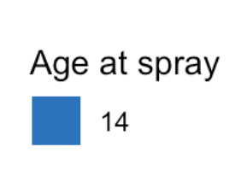

A

B

C

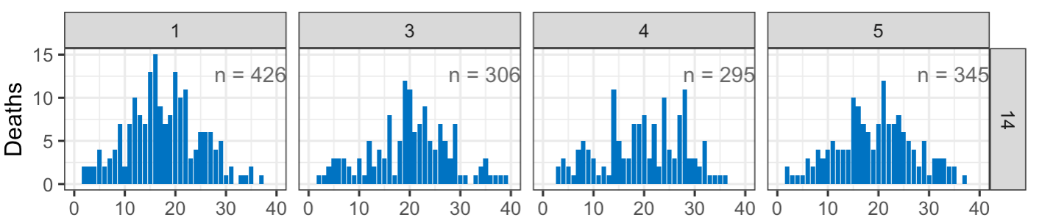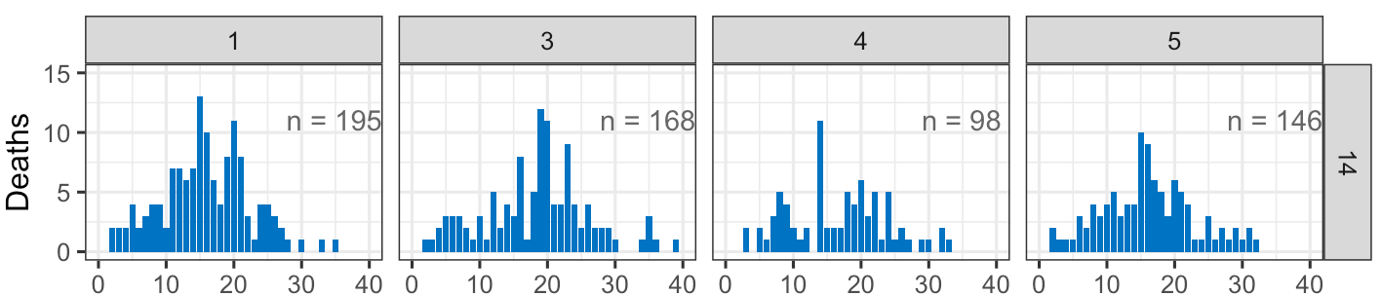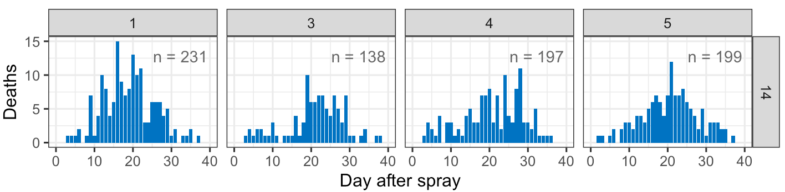

*Figure 2.* Daily mortality of control ACO. Death count of ACO control (not sprayed) flies at age 14 days of replicate 1, 3, 4, and 5. Combined sexes (A), males (B), and females (C). Each bar represents the number of dead flies at each day. On the top right corner, we list out the sample sizes per sex per replicate.



A

B

C

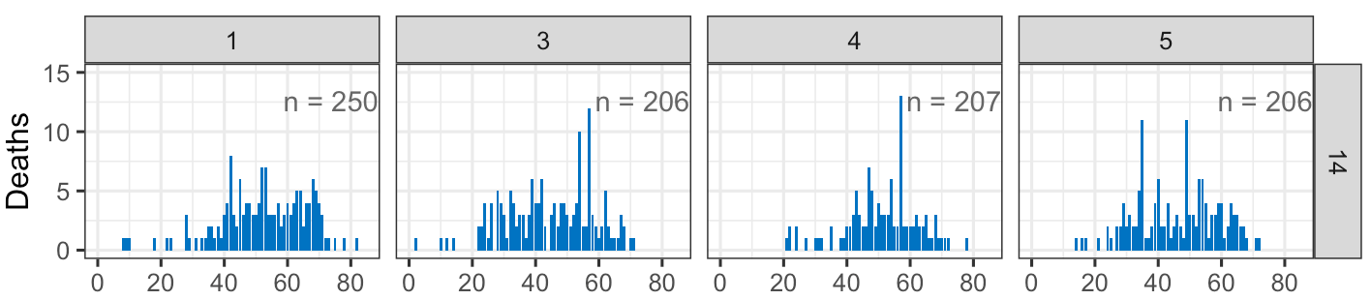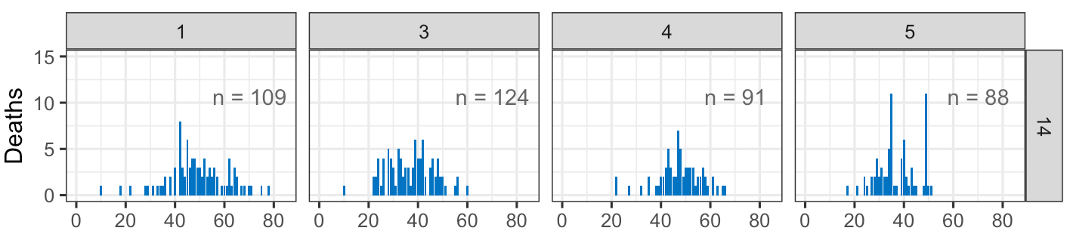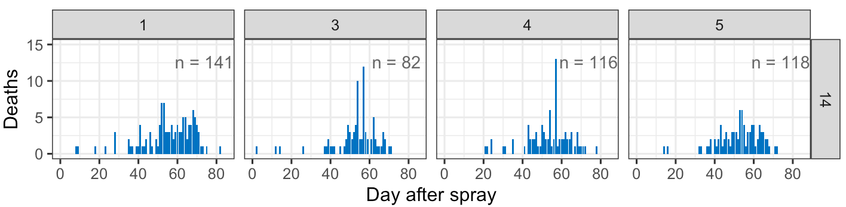

*Figure 3.* Daily mortality of control CO.Death count of CO control (not sprayed) flies at age 14 days of replicate 1, 3, 4, and 5. Combined sexes (A), males (B), and females (C). Each bar represents the number of dead flies at each day. On the top right corner, we list out the sample sizes per sex per replicate.

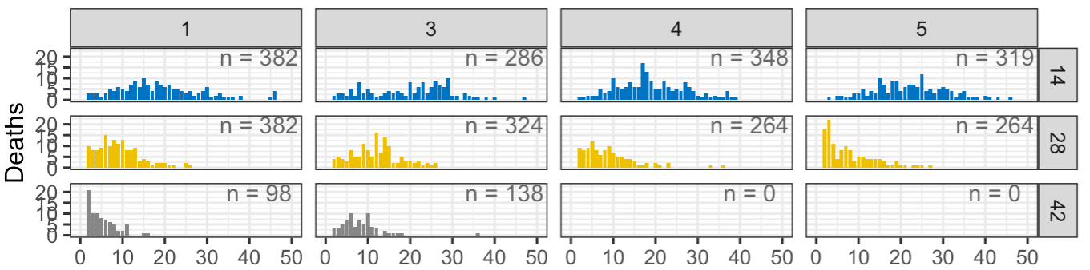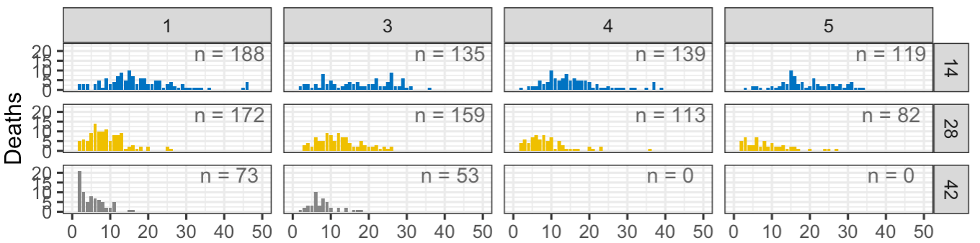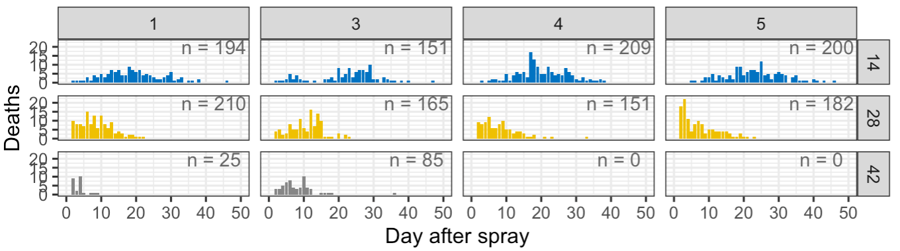

A

B

C

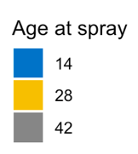

*Figure 4.* Daily mortality of uninfected ACO. Death counts of ACO un-infected flies at adult ages 14 (blue), 28 (yellow), and 42 (gray) days of replicate 1, 3, 4, and 5. Combined sexes (A), male flies (B), and female flies (C). The un-infected flies were sprayed with Silwet. Each bar represents the number of dead flies at each day after the spray. On the top right corner, we list out the sample sizes per sex per age per replicate.

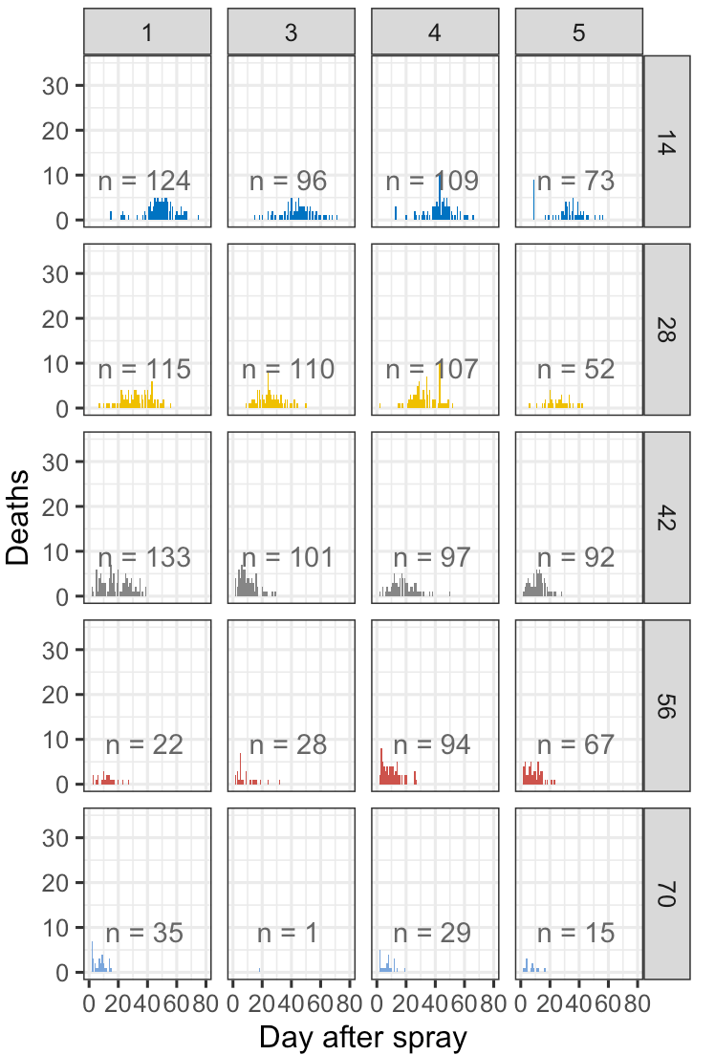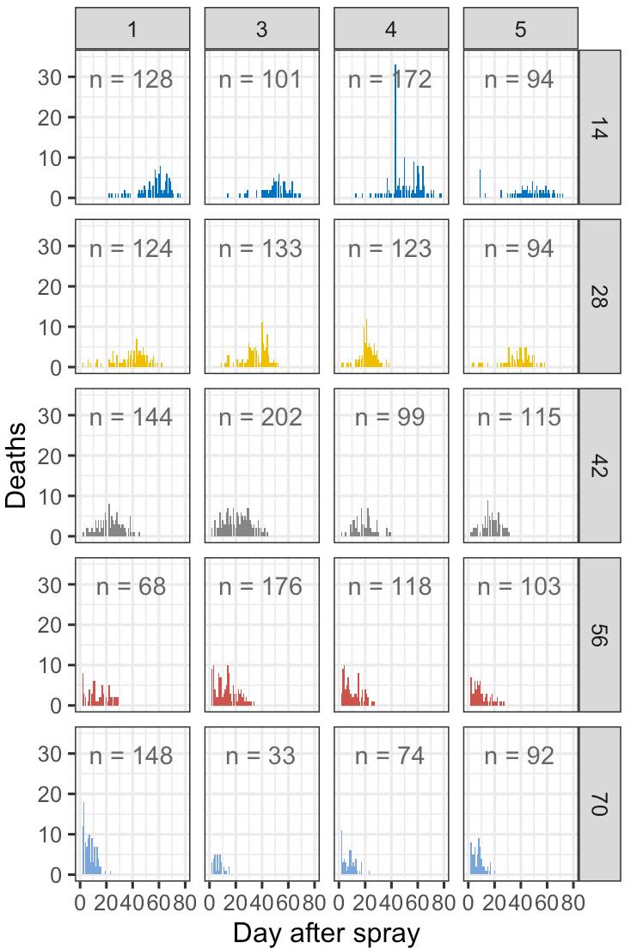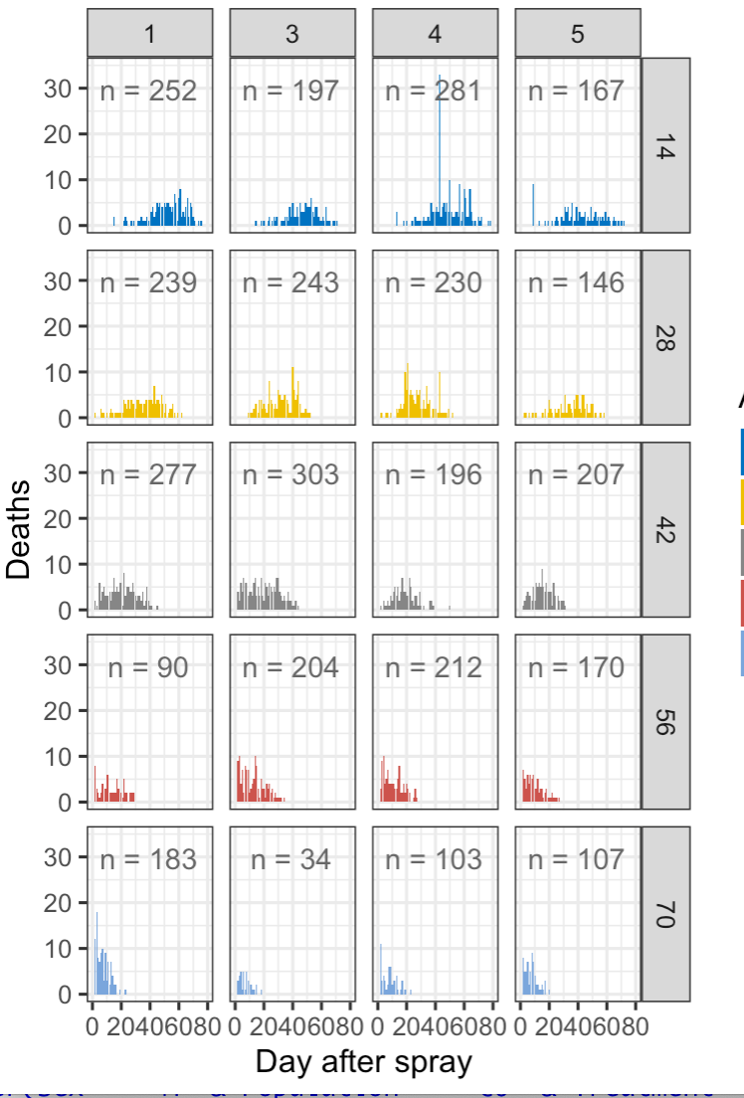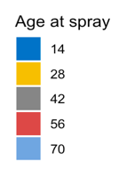

A

B

C

*Figure 5.* Daily mortality of uninfected CO. Death counts of CO un-infected flies at adult ages 14 (dark blue), 28 (yellow), 42 (gray), 56 (red), and 70 (light blue) days of replicate 1, 3, 4, and 5. Combined sexes (A), male flies (B), and female flies (C). The un-infected flies were sprayed with Silwet. Each bar represents the number of dead flies at each day after the spray. On the top right corner, we list out the sample sizes per sex per age per replicate.

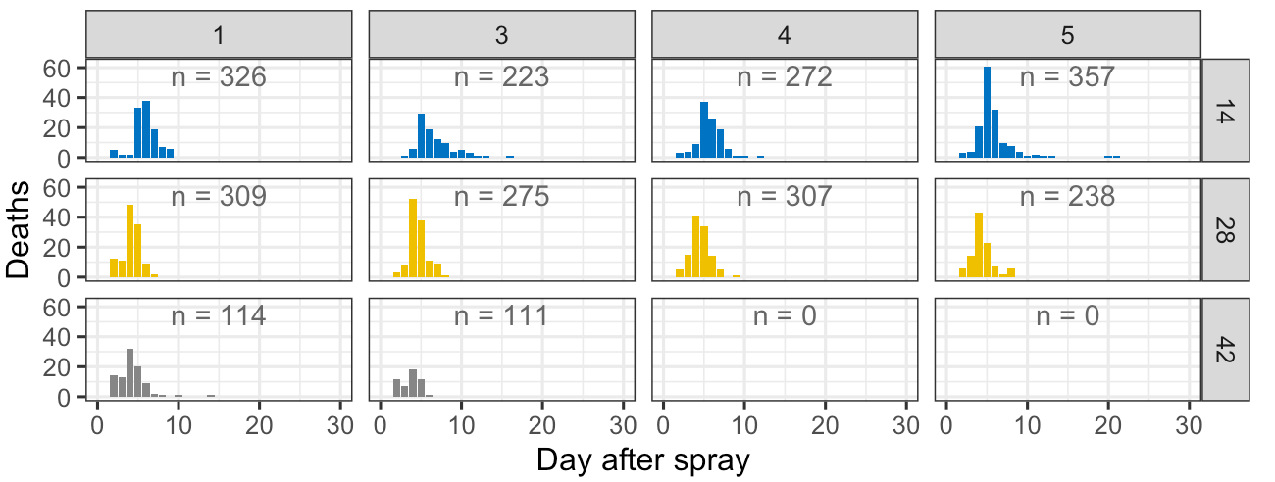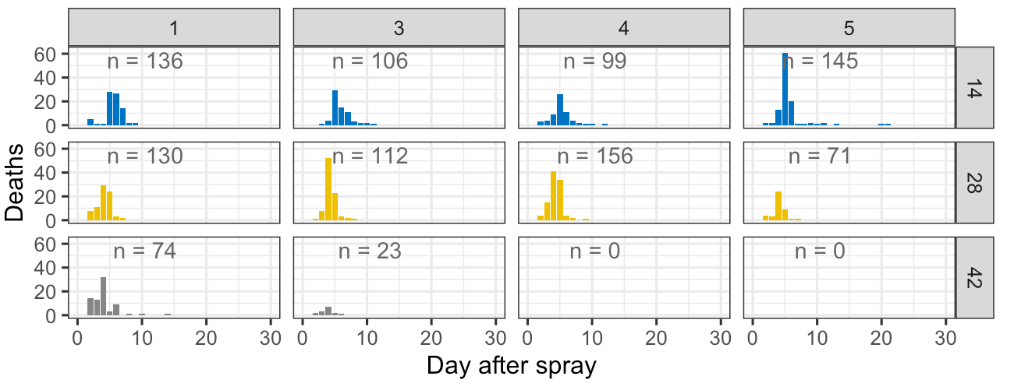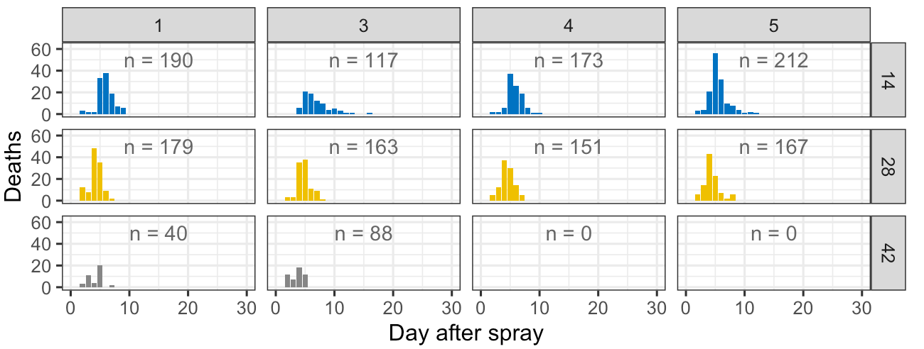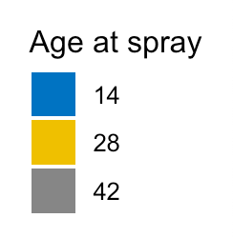

A

B

C

*Figure 6.* Daily mortality of infected ACO. Death counts of ACO infected flies at adult ages 14 (blue), 28 (yellow), and 42 (gray) days of replicate 1, 3, 4, and 5. Combined sexes (A), male flies (B), and female flies (C). Infected groups of flies were sprayed with fungus suspended in Silwet.

Each bar represents the number of dead flies at each day after the spray. On the top right corner, we list out the sample sizes per sex per age per replicate.

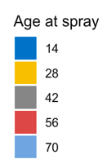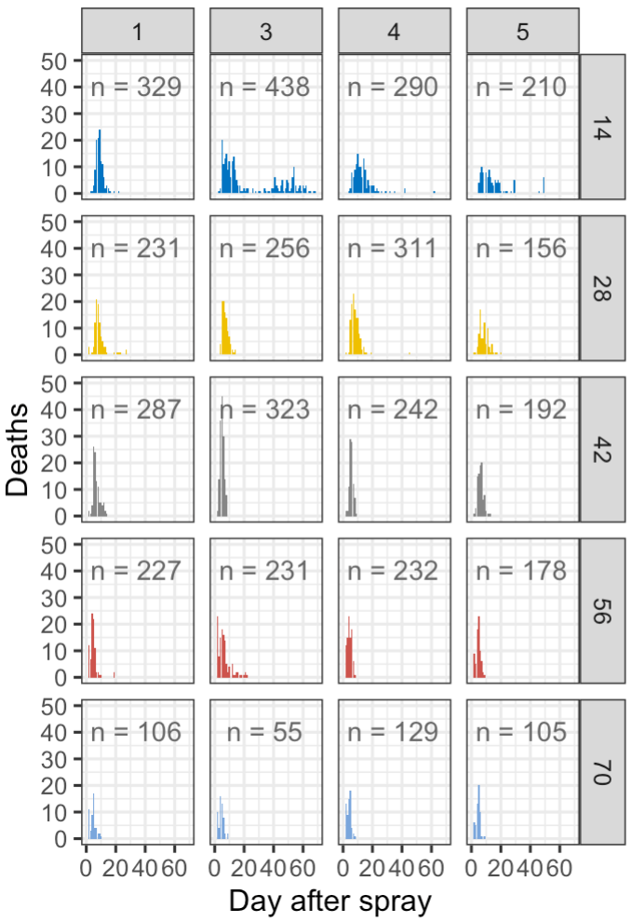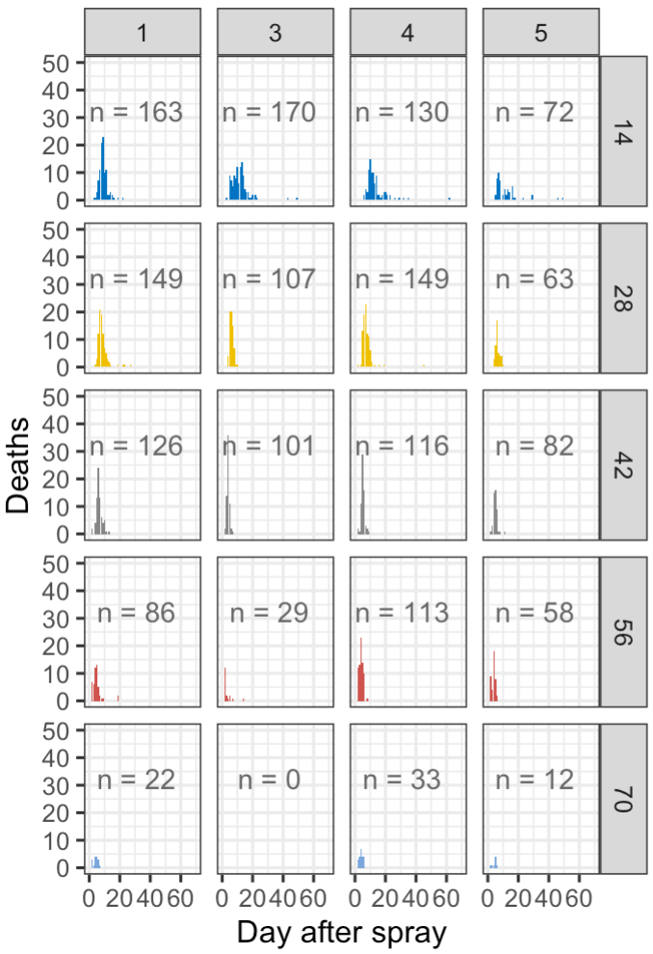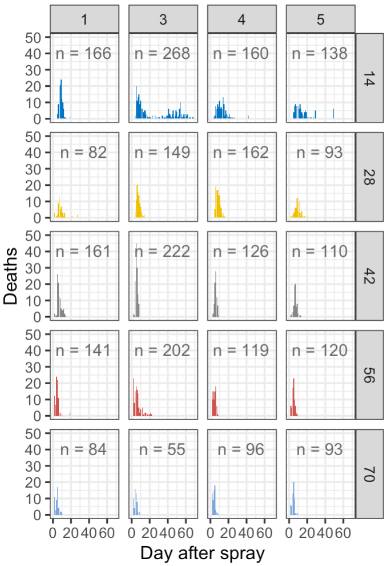

A

B

C

*Figure 7.* Daily mortality of infected CO. Death counts of CO infected flies at adult ages 14 (dark blue), 28 (yellow), 42 (gray), 56 (red), and 70 (light blue) days of replicate 1, 3, 4, and 5. Combined sexes (A), male flies (B), and female flies (C). Infected groups of flies were sprayed with fungus suspended in Silwet. Each bar represents the number of dead flies at each day after the spray. On the top right corner, we list out the sample sizes per sex per age per replicate.

Survival percent plots: The observed survival percent of control ACO flies, uninfected flies and infected at ages 14, 28, and 42 days was plotted (see Figure 8). The survival percent on day t was calculated by 1 minus the cumulative death count until day t divided by the total number of flies. Survival percent of CO control, uninfected, and infected flies at ages 14, 28, 42, 56, and 70 days was plotted (see Figure 9). A comparison of the survival of infected ACO versus CO flies at ages 14, 28, and 42 was plotted (see Figure 10). Here too, survival percent on day t after treatment was calculated by 1 minus the cumulative death count till day t divided by the total number of flies.

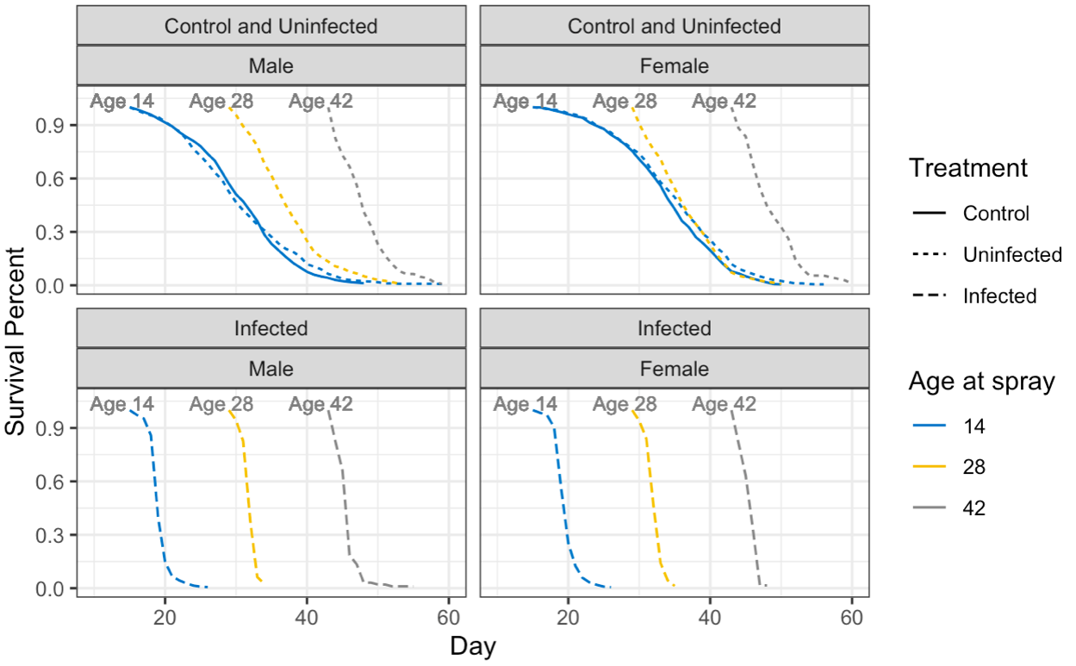

A

B

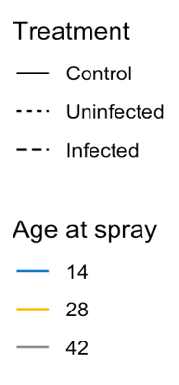

*Figure 8.* Survival of control, uninfected, and infected ACO. Comparison of survival percent of control (solid lines), un-infected (dot lines), and infected (dashed lines) ACO1,3-5 flies at age 14 (blue), 28 (yellow), and 42 (gray) days are shown in both panels A (male flies) and B (female flies). Y axis shows survival percent and x axis shows age from egg. The observed survival percent on day t is calculated by 1 minus the cumulative death count till day t divided by the total number of flies.

A

B

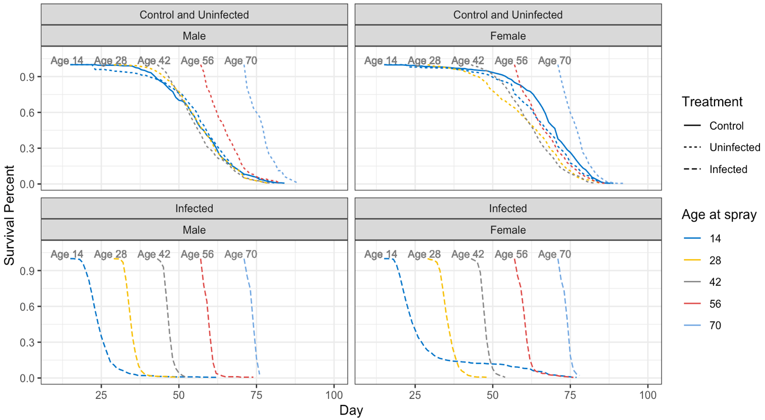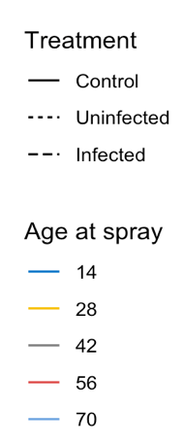

*Figure 9*. Survival of control, uninfected, and infected CO. Comparison of survival percent of control (solid lines), un-infected (dot lines), and infected (dashed lines) CO1,3-5 flies at age 14 (dark blue), 28 (yellow), 42 (gray), 56 (red), and 70 (light blue) days are shown in both panels A (male flies) and B (female flies). Y axis shows survival percent and x axis shows age from egg. The observed survival percent on day t is calculated by 1 minus the cumulative death count till day t divided by the total number of flies.

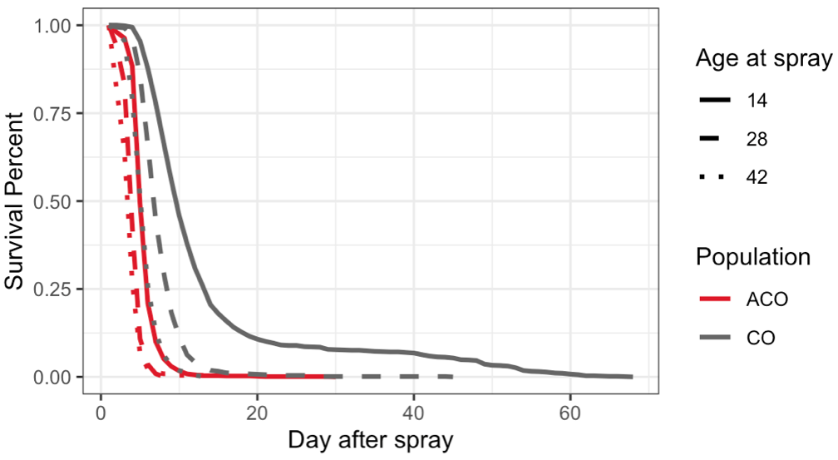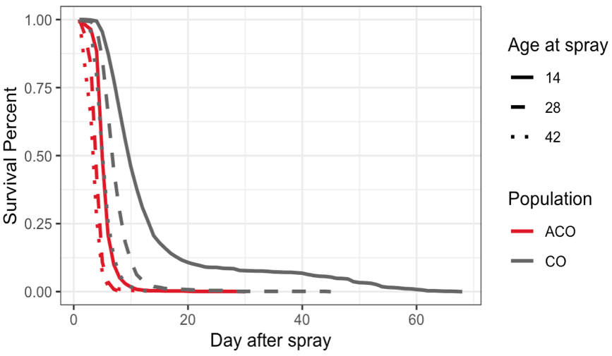

*Figure 10.* Survival of infected ACO and CO. Percent survival of infected ACO1,3-5 (red lines) and CO1,3-5 (gray lines)populations at age 14 (solid lines), 28 (dash lines), and 42 (dot lines) days. Y axis displays survival percent and X axis shows day after spray. Visual comparison of infected ACOand COflies demonstrates that survival percent of ACO populations at age 14 overlapped with survival percent of CO populations at age 42. The observed survival percent on day t after treatment is calculated by 1 minus the cumulative death count until day t divided by the total number of flies.

Median time to death plots: The observed median life time of infected ACO and infected CO populations at age 14, 28, 42, 56, and 70 days was plotted (see Figure 11). Each bar represents the 50th percentile of flies’ life time of the group. A 95% confidence interval is added on the bar to show how widely the observed life time spreads. The confidence intervals are computed by calculating: median – 1.96*standard deviation, median + 1.96* standard deviation (see Figure 11).

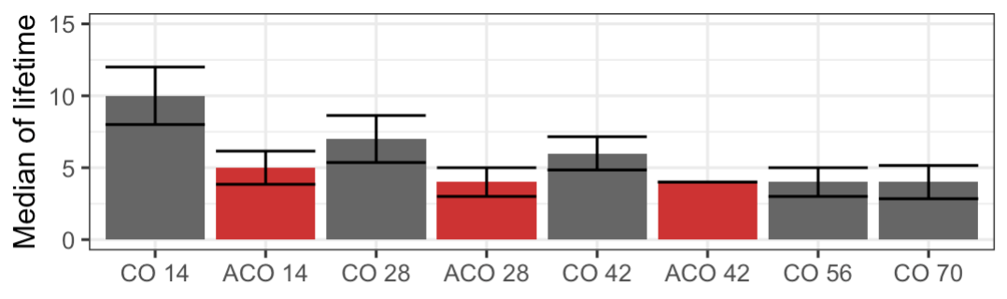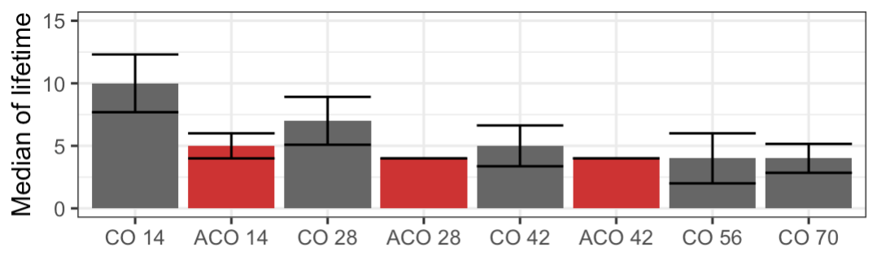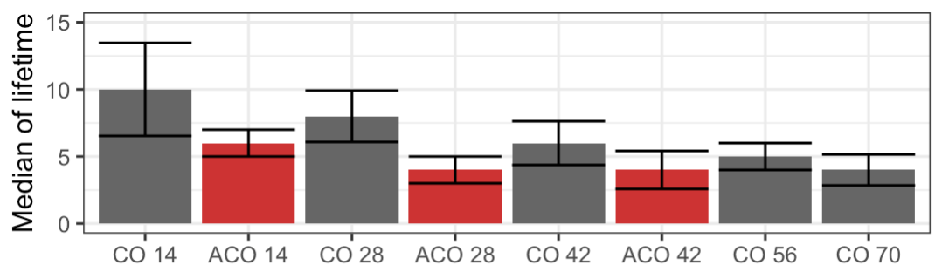

A

B

C

*Figure 11*. Median lifetime of ACO and CO. Median time to death of ACO1,3-5 (red boxes) and CO1,3-5 (gray boxes) populations were compared together at age 14, 28, 42, 56, and 70 days. Y axis shows median of lifetime and X axis shows populations’ name and ages. Panels A, B and C show results for combined sexes, male, and female flies respectively. Each bar represents the 50th percentile of flies’ life time of the group. A 95% confidence interval is added on the bar. The confidence intervals are computed by (median – 1.96*standard deviation, median + 1.96* standard deviation)

Logistic Regression

We use a generalized linear model (GLM) with a logit link function on the infected and un-infected ACO at age 14, 28, 42 days and CO flies at age 14, 28, 42, 56, and 70 days.  The GLM model used was used to measure mortality rate: age ~ day * selection * treatment + sex.

Only days 14 and 28 allow a comparison of selection regime differences because there are the only ages at which there are sufficient numbers of flies from both treatments. Within the ACO and within the CO, we compared across the age classes. The most robust analysis of age-specific differences will be done with the CO population comparing at all ages the fungal treated flies versus the controls since the CO population was tested at five different ages. The coefficient estimates of the GLM model and related p-values are summarized in Table 1, 2, and 6. We compare the estimate to zero. If the estimate is above 0, we say this variable makes it more likely to die. We also used the GLM model to estimate the t50 for each group, how many days it takes for half of the population to die. Also, the model allows us to calculate the pairwise difference on t50 and related confidence intervals.

Exponentiated Weibull Regression Model

First, we fit an exponentiated Weibull regression model on the survival data of control flies and uninfected flies of ACO and CO populations. The observed survival percent calculated by 1 minus the cumulative death count till day t divided by the total number of flies. The estimates of survival function obtained from the model is close to the raw data. 95% credible intervals using Bayesian simulations are added to the estimates of survival function.

Another approach we took to determine the immunity’s change of ACO1-5 populations and CO1-5 populations when introduced to fungus *B. bassiana*, was to use the exponentiated-Weibull regression model (Mudholkar & Srivastava, 1993) with Markov chain Monte Carlo (MCMC) sampling methods Gibbs sampler (Geman & Geman, 1984) and Metropolis-Hastings (Hastings, 1970) algorithm to assess properties of survival function, hazard ratio, and percentage of change on scale parameters as a measurement for immunity. It assumes the time to death of a fly follows an exponentiated-Weibull distribution with shape parameters, and scale parameter, where the scale parameter is an exponentiated linear combination of covariates treatment, sex, age groups, and any interaction terms. Using prior distributions $α∼\exp\left(\frac{1}{3}\right),θ∼\exp\left(\frac{1}{2}\right)$ and $β_{i}∼normal(0,100)$, the sampling methods simulated 800,000 to 1,000,000 draws from posterior distributions of $(α,θ,β_{i}'s)$. First 200,000 to 300,000 draws before convergence had been burned in. The remaining and convergent draws had been diagnosed for autocorrelation and thinned by taking one draw every 200 to 250 iterations to reduce the final autocorrelation in the samples. After MCMC diagnosis, there are at least 2,000 draws for $(α,θ,β_{i}'s)$. Using the final simulated draws, we computed the estimates and 95% credible intervals of shape parameters, covariate coefficients, survival functions, and hazard ratios.

The simulated data allows us to calculate the percentage of change on scale parameters ’s as a measurement of immune defense. Holding the shape parameters $α,θ$ as constant, the survival function is stretched out to the right as increases in value and pushed toward the initial experiment day as decreases in value. Hence, we first computed infected and uninfected for an infected group and an uninfected group of the same population at the same age, for example ACO at age 14. Next we computed $\frac{σ_{infected }- σ_{uninfected}}{σ_{infected}}$ to quantify the percentage of change between an infected group to the uninfected using scale parameters. If the quantity is smaller enough compared to another, this group has better immunity. For example, the one of ACO at age 14 is smaller than the one of ACO at age 28, we conclude that the immunity of ACO at age 14 is better than the immunity of ACO at age 28.

We applied an exponentiated Weibull regression model on the survival data of ACO and CO populations to shows the estimates of survival function obtained from the model, which is close to the raw data plot of observed survival percent. 95% credible intervals using Bayesian simulations are added to the estimates. The exponential Weibull regression model also allows us to assess the sexual dimorphism in terms of survival using hazard ratios. This model was used to show hazard ratio and related 95% credible intervals of ACO Infected (red lines) and un-infected (blue lines) at all ages (14, 28, and 42 days). We compare the hazard ratio to one. If hazard ratio above 1, the baseline has less hazard and survives better.

By using the Bayesian simulations, we can easily compute the median residual lifetime and related 95% credible intervals for ACO and CO populations. The median residual lifetime is the length of the interval from current time t0 to the time where one-half of the flies alive at time t0 will still be alive. This quantity may give us some insights on immunity measurement. we can also easily compute the percent of change on scales and related 95% credible intervals for ACO and CO populations through Bayesian simulations.

Based on exponentiated Weibull regression model per age, we have been able to find the immunity measurements to compare ACO and CO populations of the same age.

CHAPTER 3

RESULTS

Logistic Regression

The survival curves (see Figure 8, Figure 9, Figure 10) and the mortality curves along with the GLM model estimates (see Figure 12, Figure 13, Figure 14) suggest that infected flies die faster than uninfected flies and that at every age the ACO flies die faster than the CO flies regardless of infection status.

Based on the summary table of coefficient estimates of the GLM model and related p-values, male flies are more likely to die than the female flies for both ACO and CO populations at age 14 (see Table 1) and at age 28 (see Table 2). Mortality rate of ACO and CO populations at age 28 shows that in both males and females, infected flies die faster than un-infected ones and ACO flies in both infected and un-infected treatment die faster than CO flies (see Table 3, Table 4). Corroborating previous findings, ACO1-5 populations were shorter lived than CO1-5 populations (Chippindale et al., 1997).

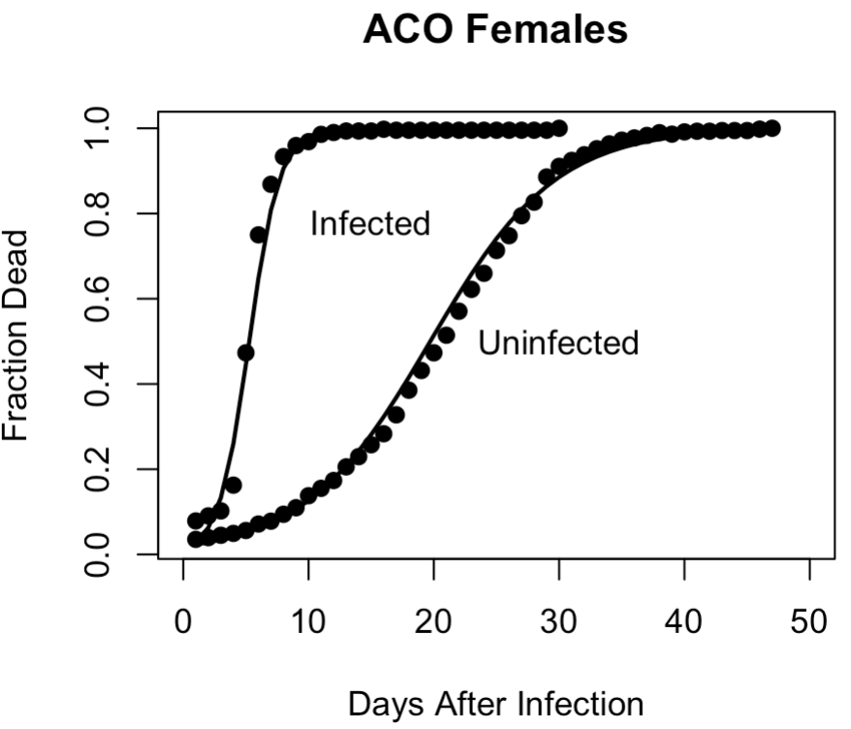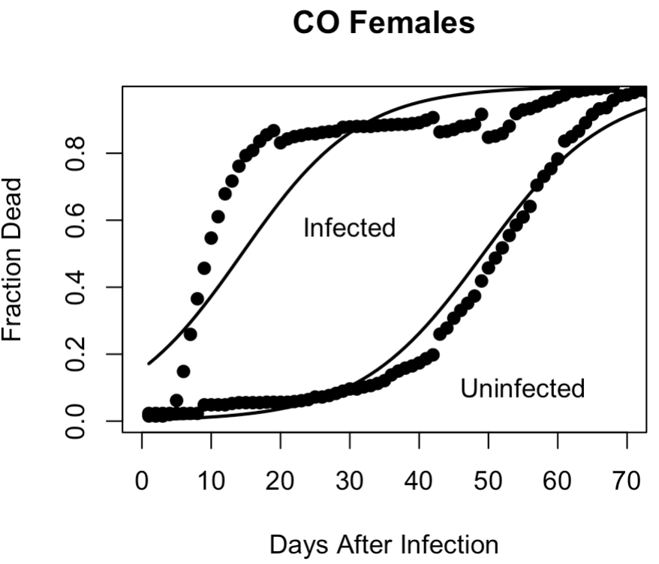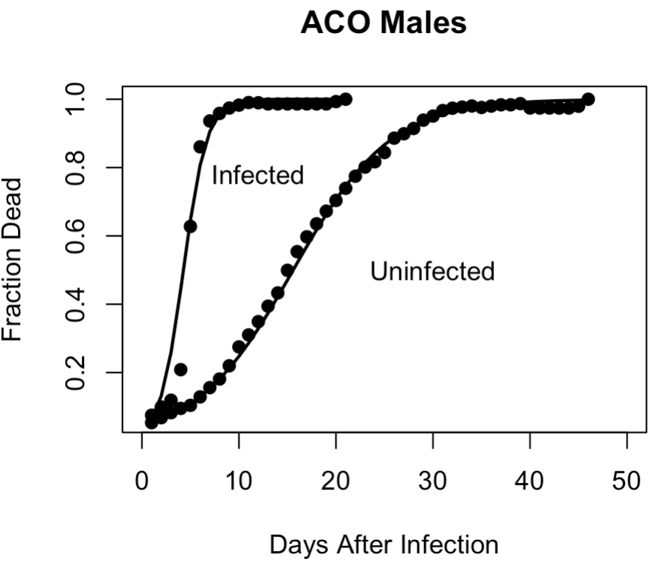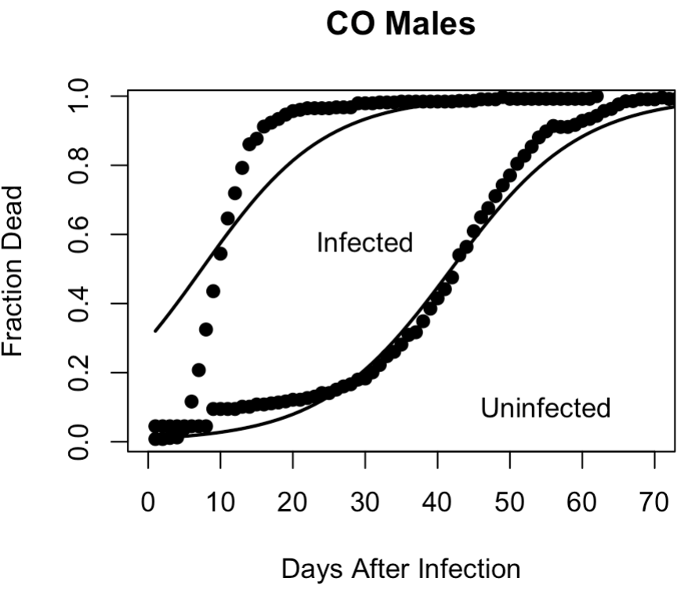

A

B

C

D

*Figure 12.* Age 14 mortality and GLM model predictions for ACO and CO.The lines are the GLM model prediction and the points are the mean observed fraction of dead flies over the four replicates. This graph shows the mortality rate comparison of infected and un-infected ACO1,3-5 and CO1,3-5 flies at age 14 days. Panels A and B show result of ACO1,3-5 males and females respectively. Panels C and D displays mortality rates for CO1,3-5 males and females respectively.

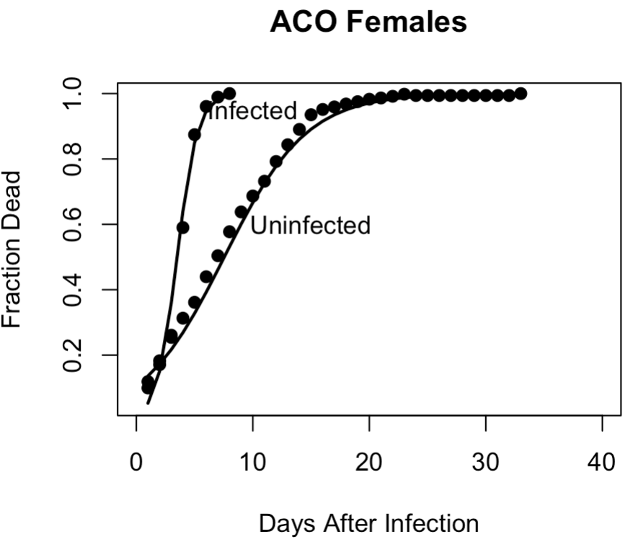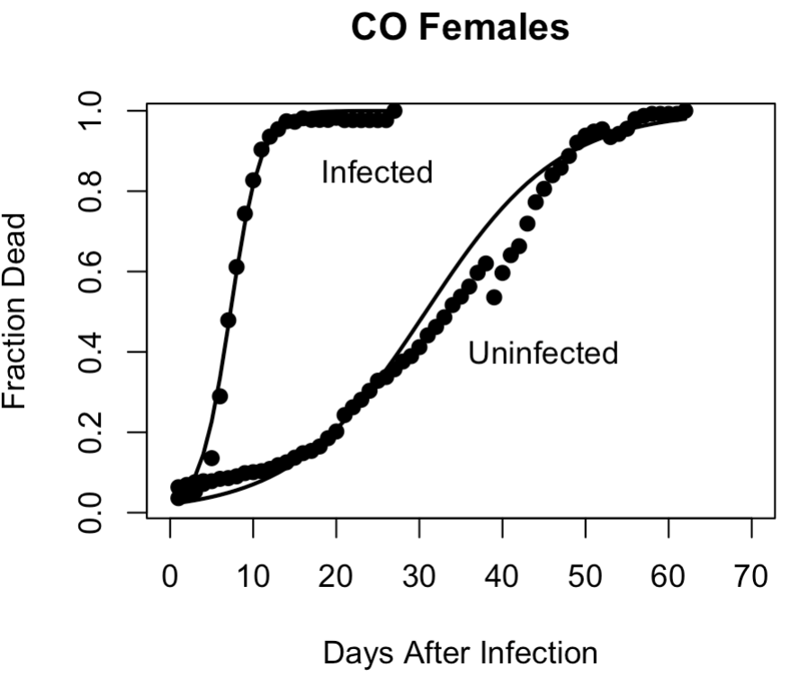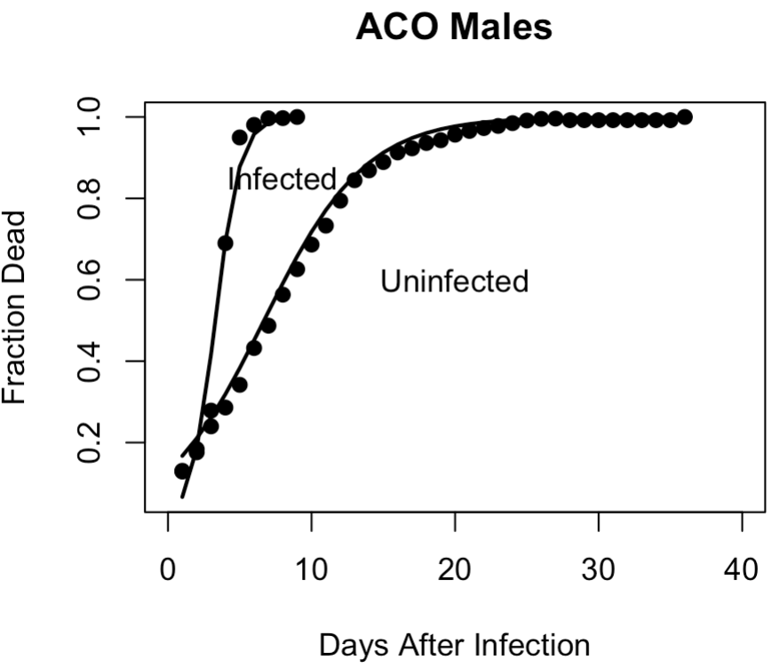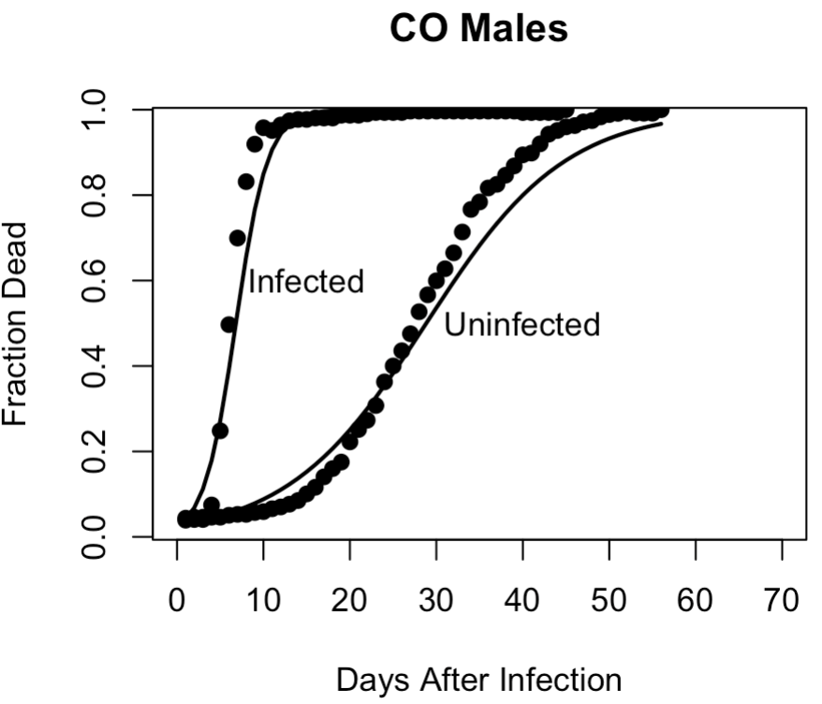

A

B

C

D

*Figure 13.* Age 28 mortality and GLM model predictions for ACO and CO.The lines are the GLM model prediction and the points are the mean observed fraction of dead flies over the four replicates. This graph shows the mortality rate comparison of infected and un-infected ACO1,3-5 and CO1,3-5 flies at age 28 days. Panels A and B show result of ACO1,3-5 males and females respectively. Panels C and D displays mortality rates for CO1,3-5 males and females respectively.

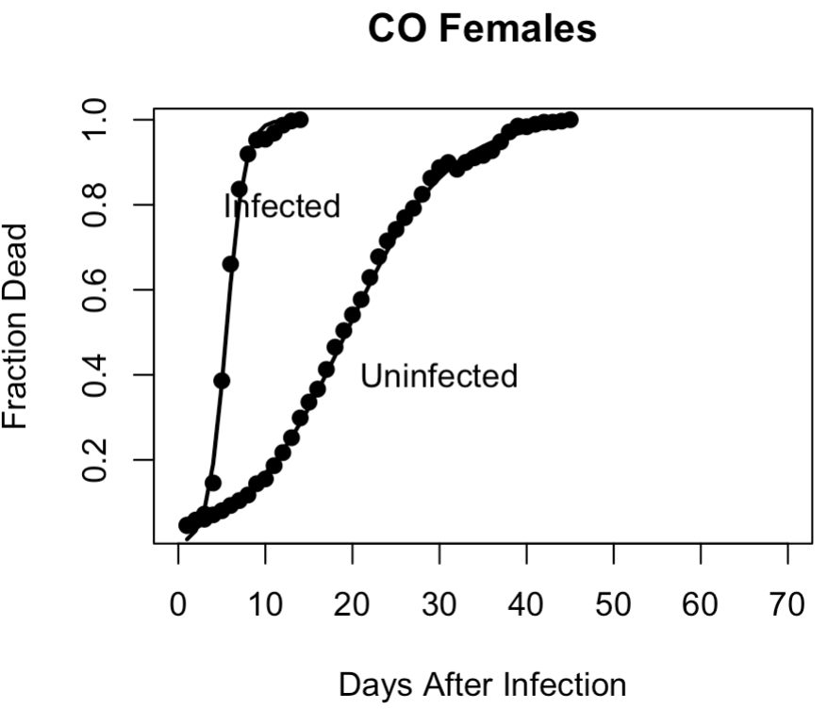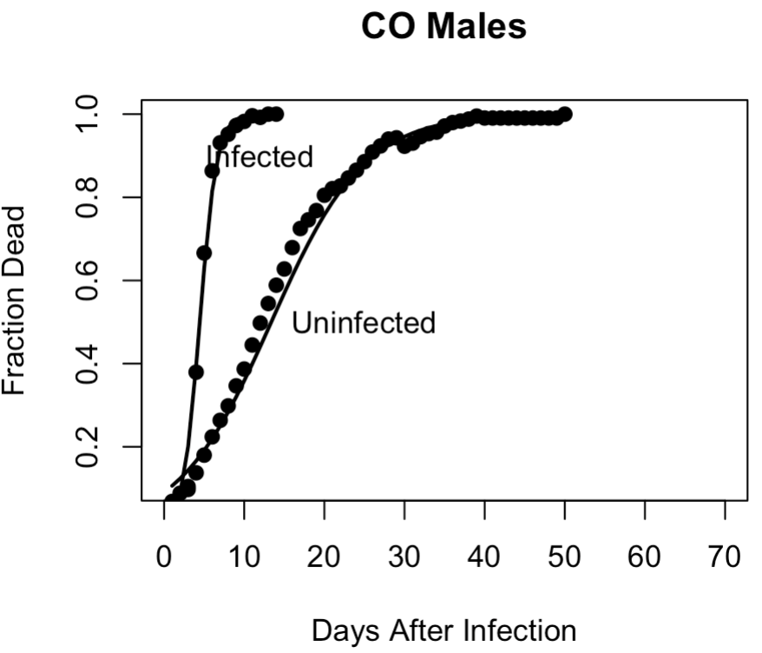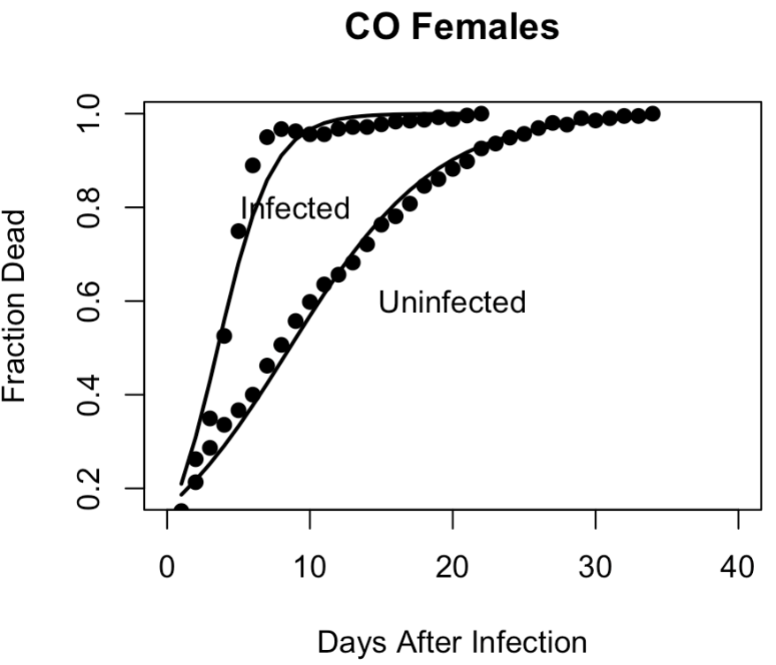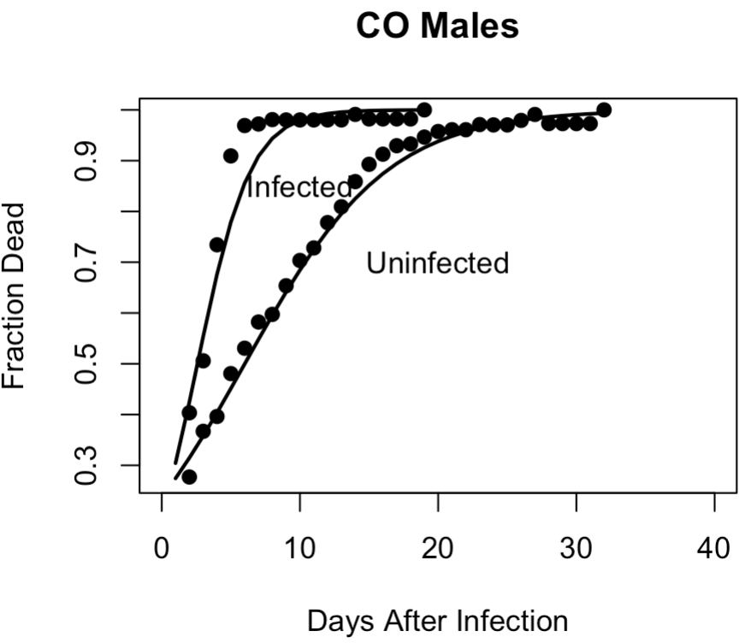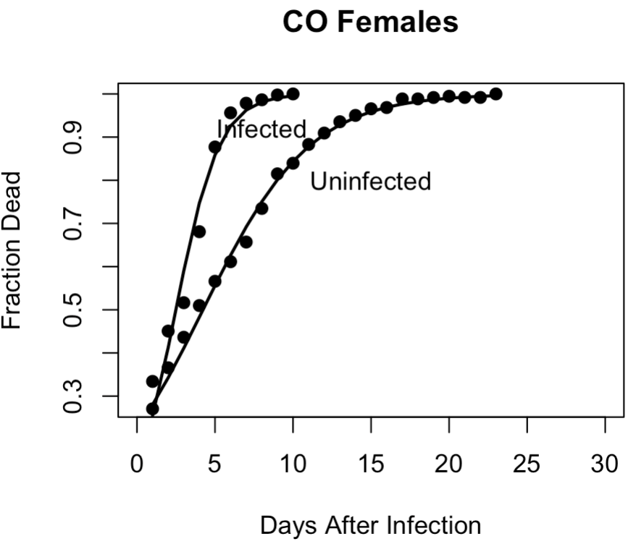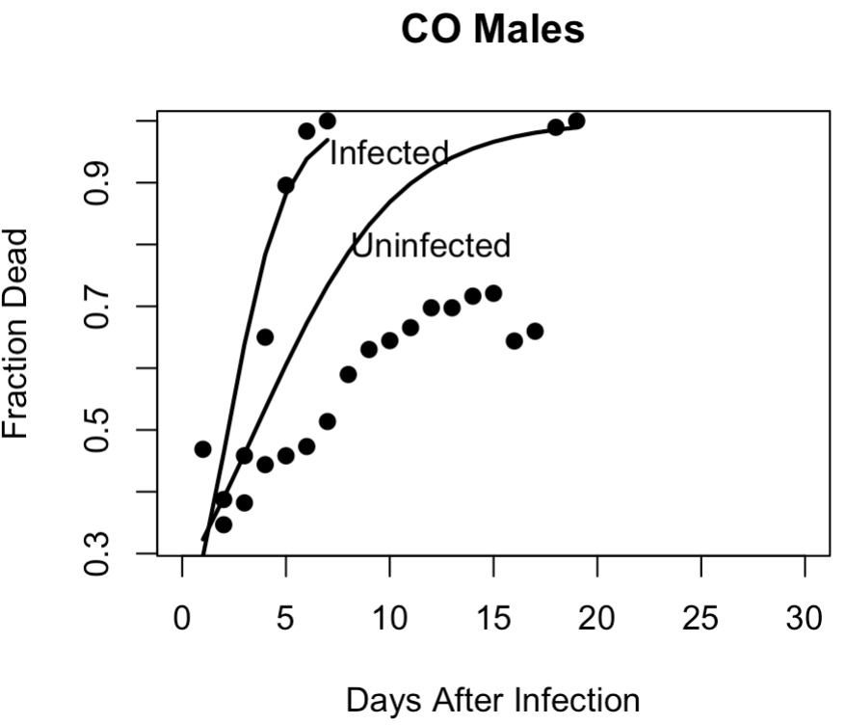

A

B

C

*Figure 14.* Ages 42, 56, and 70 mortality and GLM model predictions for CO.The lines are the GLM model prediction and the points are the mean observed fraction of dead flies over the four replicates. This graph shows the mortality comparison of infected and un-infected CO1,3-5 flies at age 42 (panel A), 56 (panel B), and 70 (panel C) days. Left figures show mortality rate for male flies and right figures show mortality rate for female flies.

Table 1*.* GLM Model Coefficient Estimates for Age 14.



This table summarizes the coefficient estimates of the GLM model and p-values at age 14. The estimate above 0 shows the variable increases chances of death.

Table 2*.* GLM Model Coefficient Estimates for Age 28.

This table summarizes the coefficient estimates of the GLM model and p-values at age 28. The estimate above 0 shows the variable increases chances of death.

Table 3.Median Time to Death Estimates from GLM Model.

28



Day

14

Using the GLM model, we can estimate how many days it takes for half of the population to die, or the t50 for each group. The top table is for day 14 and bottom table is for day 28. The impact on t50 of population, sex, and infection status is shown. If the confidence interval does not include zero we conclude that the difference is significantly different from 0.

Table 4. Uninfected Versus Infected Comparisons of T50 for Ages 14 And 28.



Day



14

28

For each comparison the difference in the t50 and related confidence intervals was calculated. This table compares the differences between uninfected groups and infected groups for the ACO and CO populations. The top table shows day 14 and bottom table shows day 28. Subscripts “i” and “u” were used for infected and uninfected treatments.

The t50 for each group shows that female flies survive better than male flies according to the model at both 14 and 28 days (see Table 3). Calculation of the pairwise difference on t50 and related confidence intervals compares the differences between uninfected groups and infected groups in terms of t50 of ACO populations and CO populations at age 14 and 28 days. Results from this table demonstrates there is significant differences between un-infected and infected groups at these ages (see Table 4). Calculation of the pairwise difference on t50 and related confidence intervals compares the differences between ACO and CO in terms of t50 with or without infection. It shows there is significant differences between ACO and CO population at both ages 14 and 28 days (see Table 5). However, this model cannot measure immunity differences between ACO and CO correctly because it does not account for a relationship between the infected and uninfected survival at the different age classes.

Table 5.ACO Versus CO Comparisons of T50 for Ages 14 And 28.



Day

14



28

The table gives the *t*50 for each of the selection-sex-treatment groups at age 14 (top table) and 28 (bottom table). The model allows us to calculate the pairwise difference on t50 and related confidence intervals to compare ACO to CO under infected and uninfected conditions.

For the CO populations, we continued to compare infected and uninfected groups at ages 42, 56, and 70. Infected CO flies at these ages die faster than un-infected ones (see Figure 14, Table 7, Table 8). Results from the table of coefficient estimates in CO populations show that males are more likely to die than the females for CO flies at these ages (see Table 6). We also can see that the CO female flies have higher t50 than the male flies under both infected and un-infected treatments at age 42,56, and 70 days. It shows female flies have higher t50 than the male flies under both infected and un-infected treatments (see Table 7). The pairwise difference on t50 and related confidence intervals for CO populations at age 42, 56, and 70 was calculated and compared the differences between uninfected groups and infected groups in terms of t50 of CO populations.

Table 6. GLM Model Coefficient Estimates for Ages 42, 56, And 70.



42 days



56 days



70 days

This table summarizes the coefficient estimates of the GLM model and p-values at age 42 (top table), 56 (middle table), and 70 (bottom table) days. The estimate above 0 shows that the variable makes it more likely to die.

Table 7.Median Time to Death Estimates From GLM Model for Ages 42, 56, And 70.



42 days

56 days

70 days

Using the GLM model, we can estimate how many days it takes for half of the population to die, or the t50 for each group at age 42 (top table), 56 (middle table), and 70 (bottom table) days. If the confidence interval does not include zero we conclude that the difference is significantly different from 0.

Table 8. Uninfected Versus Infected Comparisons of T50 at Ages 42, 56, And 70.



42 days

56 days

70 days

For each comparison the difference in the t50 and related confidence intervals was calculated. This table compares the differences between uninfected groups and infected groups for the ACO and CO populations at age 42 (top table), 56 (middle table), and 70 (bottom table) days. Subscripts “i” and “u” were used for infected and uninfected treatments.

Exponentiated Weibull Regression Model

Our model captures the difference between control and uninfected for CO female flies and identifies it as significant. Based on hazard ratio results, the CO female control group survives better than the uninfected and CO males does not show any significant difference between control and un-infected flies. While both ACO un-infected female flies and ACO un-infected male flies survive better than control flies (see Figure 15).

A

B

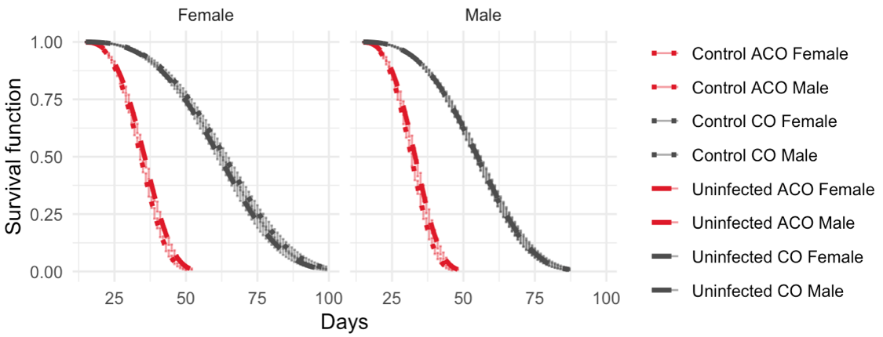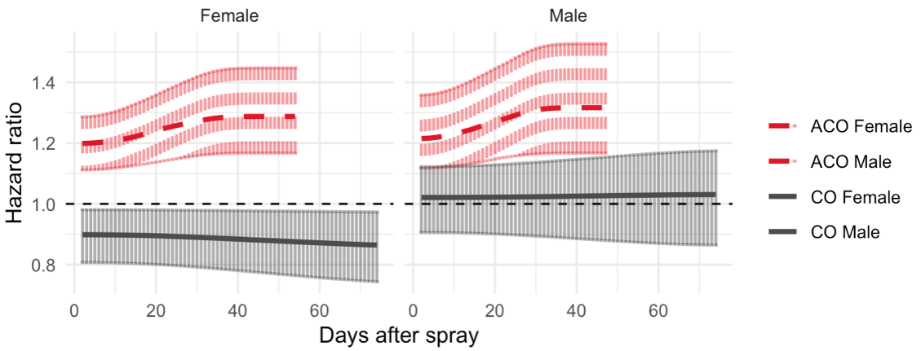

*Figure 15*. Control versus uninfected survival and hazard ratio. This figure shows survival percent in control and un-infected groups at age 14. Panel A is the model plot. In panel A, the gray color shows comparison of control CO (dot) and un-infected CO (square) groups and the red color displays comparison of control ACO (dot) and un-infected ACO (square). In panel B the base line (black line) is the un-infected group. The other groups are compared to the baseline which is set to 1. If hazard ratio above 1, the baseline has less hazard and survives better. ACO un-infected females and males survive better than controls, while CO control females survive better than un-infected females. Results from CO males does not show any significant difference between control and un-infected flies.

When comparing hazard ratios, we set a baseline equal to 1. If hazard ratio above 1, the baseline has less hazard and survives better. At age 14, females survive better than males under both treatments (see Figure 16). At age 28, male survives better than females under both treatments (see Figure 16). At age 42, since the 95% credible intervals hit the black line at 1, there is no difference between male and female in terms of survival (see Figure 16). Panel A shows the estimates of survival function obtained from the model, which is close to the raw data plot of observed survival percent. In panel A, 95% credible intervals using Bayesian simulations are added to the estimates (see Figure 16A). Panel B displays hazard ratio and related 95% credible intervals of ACO Infected (red lines) and un-infected (blue lines) at all ages 14, 28, and 42 days (see Figure 16B). In CO populations at age 14 to 56, female survives better than males under both treatments and no difference between male and female at age 70 with or without infection (see Figure 17). Median residual lifetime and related 95% credible intervals for ACO and CO populations give us some insights on immunity measurement. We measure the t50 by looking at how old these flies are right now and then look at the residual life and find out the t50 (see Figure 18, Figure 19).  The percent of change on scales and related 95% credible intervals for ACO and CO populations was calculated to measure immunity in ACO and CO populations. We find out the changes between uninfected and infected groups at age 14 is statistically significant smaller than age 28 and 42 days which it means younger ACO flies have better immunity than older flies (see Table 9). We also find out same results for CO populations which demonstrate younger CO flies have better immunity than older flies. Moreover, there is Significant differences between male and female immunity at age 14 and 42. Female flies show better immunity than male flies in these ages (14 and 42 days). Moreover, there is significant difference between male and female immunity at age 14 and 42 (see Table 10).

A

B

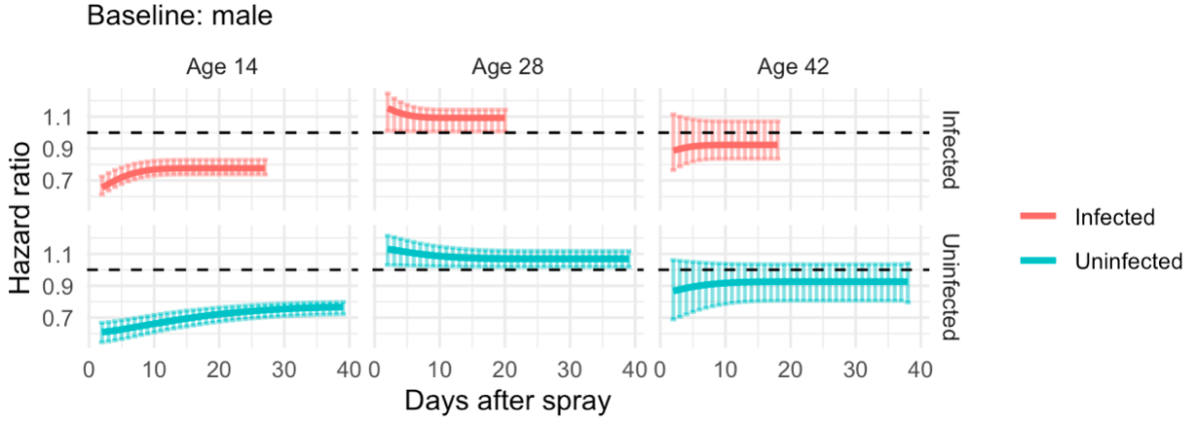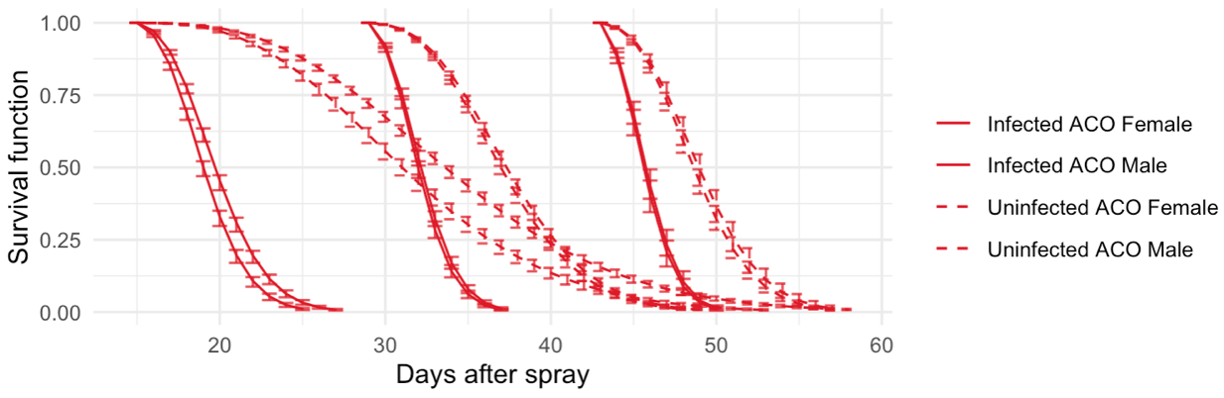

*Figure 16*. Survival function and hazard ratios for ACO. Panel A shows comparison of male and female in ACO infected (solid line) and un-infected (dash line) groups using the exponentiated Weibull regression model. This model also allows us to assess the sexual dimorphism in terms of survival using hazard ratios. Panel B displays hazard ratio and related 95% credible intervals of ACO infected (red lines) and un-infected (blue lines) at all ages (14, 28, and 42 days). Base line (black line) is male flies. If the hazard ratio is above 1, the baseline has less hazard and survives better. At age 14, females survive better than males under both treatments. At age 28, males survive better than females under both treatments and at age 42, since the 95% credible intervals hit the black line at 1, there is no difference between males and females in terms of survival.

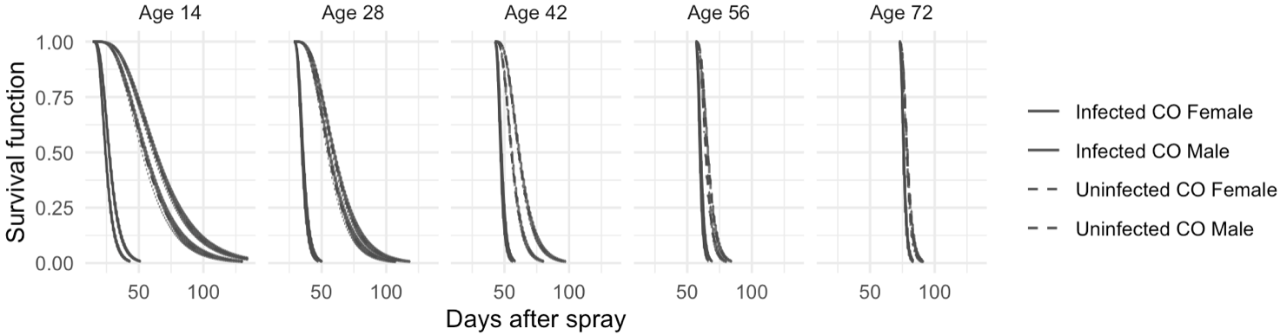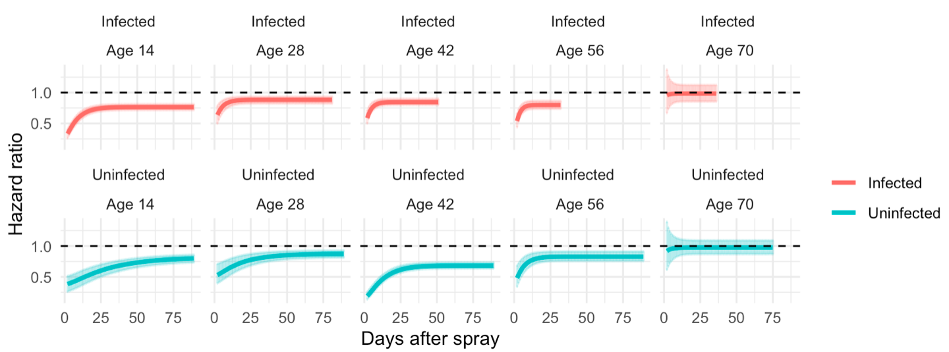

A

B

*Figure 17.* Survival function and hazard ratios for CO. Panel A shows comparison of male and female in ACO infected (solid line) and un-infected (dash line) groups using the exponentiated Weibull regression model. This model also allows us to assess the sexual dimorphism in terms of survival using hazard ratios. Panel B displays hazard ratio and related 95% credible intervals of CO Infected (red lines) and un-infected (blue lines) at all ages (14, 28,42, 56, and 70 days). Base line (black line) is male flies. If the hazard ratio is above 1, the baseline has less hazard and survives better. At ages 14 to 56, female survives better than males under both treatments and there is no difference between males and females at age 70 with or without infection.

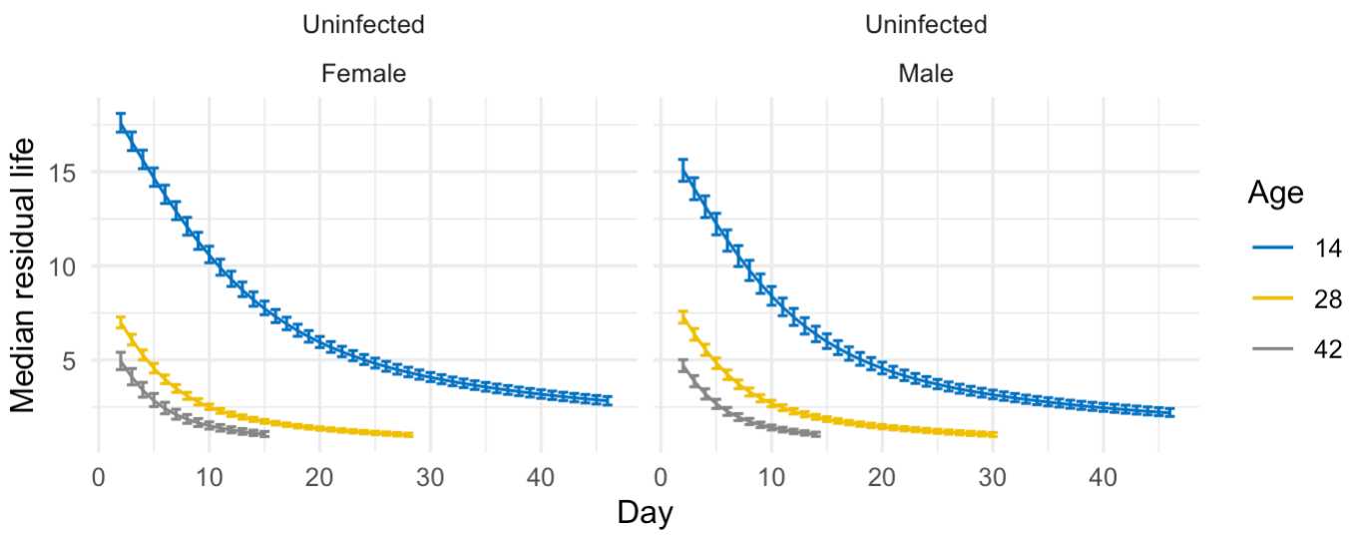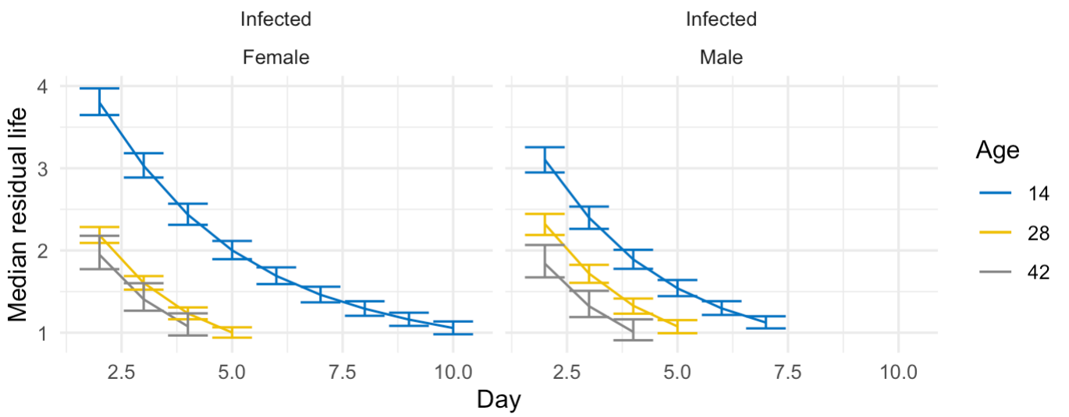

A

B

*Figure 18.* Median residual lifetime for ACO. Using the Bayesian simulations, we compute the median residual lifetime and related 95% credible intervals for ACO populations. The median residual lifetime is the length of the interval from current time t0 to the time where one-half of the flies alive at time t0 will still be alive. This quantity may give us some insights on immunity measurement. Panel A shows median residual life in un-infected ACO and Panel B shows median residual life time in infected ACO at age 14 (blue line), 28 (yellow line), and 42 (gray line). Day is days after the spray.

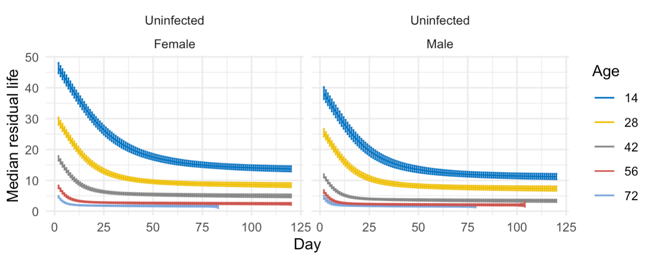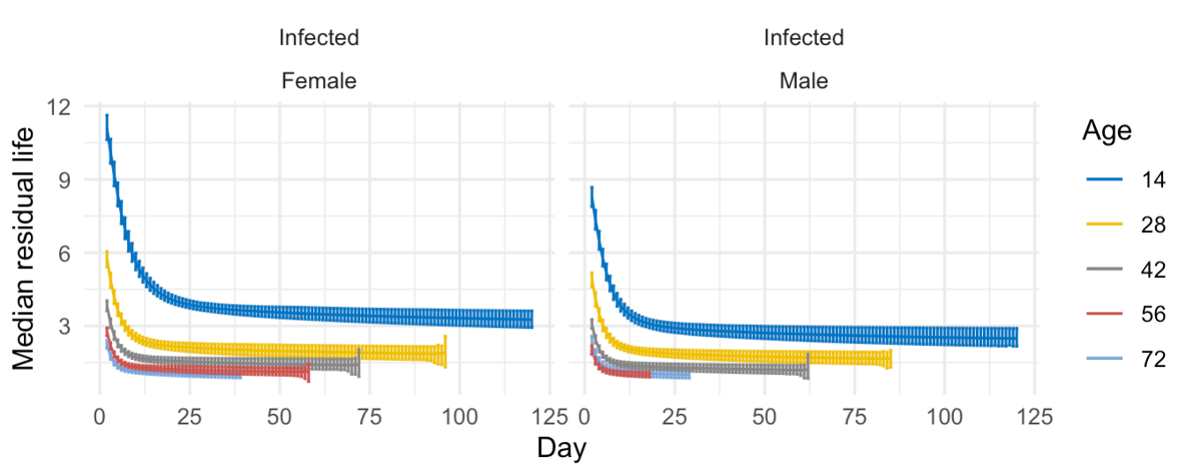

B

A

*Figure 19*. Median residual lifetime for CO. Using the Bayesian simulations, we compute the median residual lifetime and related 95% credible intervals for CO populations. The median residual lifetime is the length of the interval from current time t0 to the time where one-half of the flies alive at time t0 will still be alive. This quantity may give us some insights on immunity measurement. Panel A shows median residual life in un-infected CO and Panel B shows median residual life time in infected CO at age 14 (dark blue line) ,28 (yellow line), 42 (gray line), 56 (red line), and 72 (light blue line). Day is days after the spray.

Table 9. Immunity Measurement at Different Ages in ACO.

|  |  |  |  |
| --- | --- | --- | --- |
| Age | Sex | Estimates | 95% Intervals |
| Age 14 | Female | 0.01631 | (0.01514, 0.01730) |
| Male | 0.01885 | (0.01754, 0.02019) |
| Age 28 | Female | 0.05403 | (0.04800, 0.05881) |
| Male | 0.05208 | (0.04746, 0.05798) |
| Age 42 | Female | 0.08421 | (0.07605, 0.09671) |
| Male | 0.08925 | (0.08141, 0.10134) |

Using the Bayesian simulations, we computed the percent of change on scales and related 95% credible intervals for ACO populations. These are the changes of scales between infected and uninfected ACO based on sigma formula ($\frac{σ_{infected }-σ_{uninfected} }{σ_{uninfected}}$). Sigma is called scale parameter. 95% intervals at age 14 is smaller than age 28 and 42. If the quantity is small, we say the change between two groups is small.

Table 10. Immunity Measurement at Different Ages In CO.

|  |  |  |  |
| --- | --- | --- | --- |
| Age | Sex | Estimates | 95% Intervals |
| Age 14 | Female | 0.01070 | (0.00977, 0.01187) |
| Male | 0.01202 | (0.01122, 0.01316) |
| Age 28 | Female | 0.01544 | (0.01415, 0.01678) |
| Male | 0.01722 | (0.01589. 0.01850) |
| Age 42 | Female | 0.03127 | (0.02786, 0.03391) |
| Male | 0.05107 | (0.04625 ,0.06039) |
| Age 56 | Female | 0.09071 | (0.08209, 0.10411) |
| Male | 0.09939 | (0.08022, 0.11243) |
| Age 70 | Female | 0.17654 | (0.15904, 0.20335) |
| Male | 0.19171 | (0.16092, 0.22467) |

Using the Bayesian simulations, compute the percent of change on scales and related 95% credible intervals for CO populations. These are the changes of scales between infected and uninfected CO based on sigma formula ($\frac{σ_{infected }-σ_{uninfected} }{σ_{uninfected}}$). Sigma is called scale parameter. 95% intervals at all age 14, 28 ,42, 56, and 70 are shown. If the quantity is small, we say the change between two groups is small. Significant difference between male and female immunity at age 14 and 42.

Based on results from exponentiated Weibull regression model per age, we have been able to find the CO populations have better immunity than the ACO populations of the same age (see Table 11).

Table 11. ACO Versus CO Immunity.

|  |  |  |  |  |
| --- | --- | --- | --- | --- |
| Age | Sex | Population | Estimates | 95% Intervals |
| 14 | Female | ACO | 0.04058 | (0.03522, 0.04779) |
| CO | 0.01410 | (0.01254, 0.01410) |
| Male | ACO | 0.06329 | (0.05398, 0.07544) |
| CO | 0.01712 | (0.01448, 0.02005) |

|  |  |  |  |  |
| --- | --- | --- | --- | --- |
| Age | Sex | Population | Estimates | 95% Intervals |
| 28 | Female | ACO | 0.06155 | (0.05549, 0.06874) |
| CO | 0.00857 | (0.00778, 0.00943) |
| Male | ACO | 0.04694 | (0.04214, 0.05327) |
| CO | 0.01014 | (0.00929, 0.01130) |

|  |  |  |  |  |
| --- | --- | --- | --- | --- |
| Age | Sex | Population | Estimates | 95% Intervals |
| 42 | Female | ACO | 0.07634 | (0.06126, 0.09586) |
| CO | 0.01554 | (0.01380, 0.01796) |
| Male | ACO | 0.10163 | (0.08395, 0.12585) |
| CO | 0.02391 | (0.02089, 0.02820) |

We built an exponentiated Weibull regression model per age using the Bayesian simulations to find the immunity measurements to compare ACO and CO populations of the same age.

CHAPTER 4

DISCUSSION

As expected from the evolutionary theories of aging and late life, our mortality results show that among control flies, the ACO die faster than the CO, which support the theory that populations with different first age of reproduction have different longevity. Populations that have evolved to age at different rates may allow us to separate biological aging from the effects of time and cumulative exposure, whereas studies of aging that compare young and old flies from the same population are looking at “chronological” aging, which can be affected by extended interactions with the biotic and abiotic factors in the environment. In this study, we examined the effects of chronological aging and biological aging on immune defense in *D. melanogaster*. We observed that long-lived populations survive infection better than short lived populations at all ages. Moreover, younger flies in each population have better immunity than older ones. The percent of change on scales and related 95% credible intervals for ACO and CO populations was calculated to measure immunity in ACO and CO populations and results display that the changes between uninfected and infected groups at age 14 is statistically significant smaller than age 28 and 42 days which it means younger ACO and CO flies have better immunity than older flies.

Some past studies show improvements in innate immunity during aging while some others display weakening of immune defense with aging (Loch et al., 2017; Zerofsky et al., 2005). The processes of deterioration that typically accompany aging affect the immune defense, such as chronic inflammation and weakening of protective epithelial barriers. A loss of cellular immunity increased pathogen susceptibility of aging flies (Eleftherianos et al., 2012; Müller et al., 2013). Another study on immune aging described that fungal infection susceptibility increased in flies of both sexes as they age. In male flies this happened due to deterioration in barrier defenses and in females it resulted chiefly from deterioration in the systemic immune responses (Kubiak et al., 2017). Sometimes improvements in immune defense are seen with aging. One of these studies described that the gut specific provocation of Drosocin and Cecropin A1 is necessary to notably extend lifetime of adult flies. Decrease of bacterial challenges upon expression of Dro is responsible for intestinal barrier improvement which postpone intestinal and organismal ageing and lead to longer lifespan of flies (Loch et al., 2017).

Long-lived flies have better immunity upon infection (Fabian et al., 2018). In Fabian et al. (2018), they used 4 long-lived selection lines (La, Lb, 2La, 2Lb) and 2 unselected control lines (Ra, Rb). These populations were taken from an outbred base population which was founded in 1979 from ~50 flies caught in a peach orchard in Michigan. The base population was then expanded, divided into replicate lines, and selection was originated in 1981. To examine whether selected and control flies vary in recognized immune function, they infected their populations with four different pathogens and measured their survival percent after infection. Then, they found out long-lived flies have better survival upon infection. Our own study supports Fabian et al. (2018) but we used different populations of *D. melanogaster*. For our genomic analysis, we will be using 10 replicates of short-lived populations and 10 replicates of long-lived populations which should lead to more statistical power to identify the relationship between aging genes and immune defense genes than in Fabian et al. (2018) which only used 4 long-lived and 2 control populations.

The genomic differentiation between the short lived (ACO1-5 and AO1-5 – known as “A type”) and long lived (CO1-5 and nCO1-5 – known as “C type”) populations has been previously published (Graves Jr et al., 2017). Each of these 20 populations maintains high levels of heterozygosity reflecting a lack of fixations of alleles. However, the mean heterozygosity is lower in the A-type populations than in the C-type populations, perhaps due to the A-types having been under strong selection for early development. However, this lower heterozygosity in the A-type populations does not seem to indicate that alleles in these populations are moving toward fixation, as evidenced by the newly derived A-types (AO1-5) having evolved to become genomically indistinguishable from the long-standing A-types (ACO1-5) despite the vast difference in the number of generations that these populations experienced selection pressure for early development (Graves Jr et al., 2017). Indeed, most recent selection pressure seems to shape phenotypes and genomes in populations despite previous evolutionary history (Graves Jr et al., 2017; Phillips et al., 2018). In comparing frequencies of Single Nucleotide Polymorphisms (SNPs) across the A-type and C-type populations, there were 10,109 significantly differentiated SNPs (Graves Jr et al., 2017). These SNP differences appear on every chromosome, showing that these populations have diverged greatly across the entire genome. Fabian et al. (2018) suggested that populations that are differentiated for longevity are also differentiated for immune defense genes. We wanted to see if the genomic differentiation between our A-type and C-type populations is also enriched for immune defense genes. We only did very preliminary work toward this question, and much work remains to be done. Specifically, we obtained the results of Wang et al. (2017) from their online database and put their gene list into Flybase, which is a website that has gene information for *D. melanogaster*. In wang et al. (2017) two different pathogens were used. *Metarhizium anisopliae* Ma549 (ARSEF 549) which is an entomopathogenic fungus and the bacterium *Pseudomonas aeruginosa* Pa14. In this study, they found that defense to Ma549 was correlated with defense to the Pa14. Results of genomic analysis shows 50 SNPs and 4 indels related with Ma549 and 51 total associated genes and 12 indels related with Pa14. We next compared the list of 117 genes identified to have immune defense function from Wang et al. (2017) to the list of significantly differentiated SNPs between the A-type and C-type populations. This comparison returned 13 genes. However, this is only 10% of the list and it is possible that these 13 genes resulted from chance alone.

The remainder of this genomic analysis is beyond the scope of this thesis. However, the general idea is to cross-reference among lists of genes that are obtained from our genomic analysis and those obtained from genomic studies of immune defense. In other words, we would want to see if the SNPs identified by Graves Jr et al. (2017) occur within transcript regions of candidate immune defense genes. The approach that we take would need to take into account reported levels of linkage disequilibrium in our fly populations up to 100kb; cf. (Teotónio et al., 2009) as well as potentially informative noncoding genomic regions. As a way to control the analysis, we would generate an equal number of randomly chosen transcripts, sampled from all annotated transcripts in the *D. melanogaster* genome. A potential way to test for significant overlap between two gene lists would be to use the R package SuperExactTest (Wang et al., 2015).

A key difference between our study and previous studies such as Fabian et al. (2018) is that our study is focused on fungal infection and we used specific methods for our fungal spray which is different than Fabian et al. (2018). In this study, *B. bassiana* strain, ARSEF 12460, was used to infected ACO and CO populations while some other studies focused on bacterial infection and bacterial clearance ability in *D. melanogaster* (Fabian et al., 2018). *B. bassiana* is known as an entomopathogenic fungus which naturally infects many different types of insect hosts. Entomopathogenic fungi can be gathered in the field and incubated in the laboratory such as *B. bassiana* which have been documented to happen obviously in over 700 species of hosts (Inglis et al., 2001). In temperate regions, any main insect taxon gathered intensively is known as a natural host for *B. bassiana*. Moreover, genetic diversity and dispersal mechanisms of *B. bassiana* (Meyling et al., 2007) is also make it important and useful for our immune aging study.

In studies of age-specific physiology, including ours on age-specific immune defense, it should be kept in mind that for a period of 5-15 days, flies that are near death enter a phase that has been called the “death spiral” (Mueller et al., 2009). When in the death spiral, female fecundity and male virility drop significantly below that of same-aged individuals who are not near death (Mueller et al., 2016; Rauser et al., 2005; Shahrestani et al., 2012c). Several phenotypes are also known to deteriorate substantially in dying individuals, regardless of the actual age at death, including time in motion and negative geotaxis ability (Shahrestani et al., 2012a). In other words, the death spiral is a period before death during which physiological characters and life-history characters decline (Mueller et al., 2016). When individuals who are near death at any given age are eliminated from estimates of age-specific fecundity and virility, these characters still continue to decline during aging, suggesting that the age-specific decline in these characters does not result from more and more individuals entering the dying phases at older ages (Mueller et al., 2007). We expect that the age-specific decline we see in immune defense also should be independent of individuals who are dying, even if the dying individuals change the shape of the curves qualitatively.

This study interestingly examines the relationship between aging and immune defense by comparing immunity between short lived and long-lived populations at the same chronological ages, and comparing different chronological within populations. As *D. melanogaster* is a good sample to study innate immunity because of its similarity to human’s innate immunity (Buchon et al., 2014), results from studies such as this may be relevant for understanding age-specific defense against infection in humans and other organisms. Moreover, *B. bassiana* which is known as an entomopathogenic fungus is a biological control agent that can affect immune defense of different types of insects. Then, this study will also be crucial for future studies on biological control against insect vectors of human disease.

REFERENCES

Brys, K., Vanfleteren, J. R., & Braeckman, B. P. (2007). Testing the rate-of-living/oxidative damage theory of aging in the nematode model Caenorhabditis elegans. Experimental gerontology, 42(9), 845-851.

Buchon, N., Silverman, N., & Cherry, S. (2014). Immunity in Drosophila melanogaster—from microbial recognition to whole-organism physiology. Nature reviews immunology, 14(12), 796-810.

Carey, J. R., Liedo, P., Orozco, D., & Vaupel, J. W. (1992). Slowing of mortality rates at older ages in large medfly cohorts. Science, 258(5081), 457-461.

Chippindale, A. K., Alipaz, J. A., Chen, H. W., & Rose, M. R. (1997). Experimental evolution of accelerated development in Drosophila. 1. Developmental speed and larval survival. Evolution, 51(5), 1536-1551.

Chippindale, A. K., Alipaz, J. A., & Rose, M. R. (2004). Experimental evolution of accelerated development in Drosophila. 2. Adult fitness and the fast development syndrome Methuselah Flies: A case study in the evolution of aging (pp. 413-435): World Scientific.

Collatz, K.-G. (2003). Aging and environmental conditions in insects Aging of organisms (pp. 99-123): Springer.

Djawdan, M., Chippindale, A. K., Rose, M. R., & Bradley, T. J. (1998). Metabolic reserves and evolved stress resistance in Drosophila melanogaster. Physiological zoology, 71(5), 584-594.

Drapeau, M. D., Gass, E. K., Simison, M. D., Mueller, L. D., & Rose, M. R. (2000). Testing the heterogeneity theory of late-life mortality plateaus by using cohorts of Drosophila melanogaster. Experimental Gerontology, 35(1), 71-84.

Eleftherianos, I., & Castillo, J. C. (2012). Molecular mechanisms of aging and immune system regulation in Drosophila. International journal of molecular sciences, 13(8), 9826-9844.

Fabian, D., & Flatt, T. (2011). The evolution of aging. Nature Education Knowledge, 3(3), 1-10.

Fabian, D. K., Garschall, K., Klepsatel, P., Santos‐Matos, G., Sucena, E., Kapun, M., . . . Flatt, T. (2018). Evolution of longevity improves immunity in Drosophila. Evolution letters, 2(6), 567-579.

Florea, M. (2017). Aging and immortality in unicellular species. Mechanisms of ageing and development, 167, 5-15.

Geman, S., & Geman, D. (1984). Stochastic relaxation, Gibbs distributions, and the Bayesian restoration of images. IEEE Transactions on pattern analysis and machine intelligence(6), 721-741.

Gladyshev, V. N. (2012). On the cause of aging and control of lifespan: heterogeneity leads to inevitable damage accumulation, causing aging; control of damage composition and rate of accumulation define lifespan. Bioessays, 34(11), 925-929.

Gladyshev, V. N. (2013). The origin of aging: imperfectness-driven non-random damage defines the aging process and control of lifespan. Trends in genetics, 29(9), 506-512.

Graves Jr, J., Hertweck, K., Phillips, M., Han, M., Cabral, L., Barter, T., . . . Rose, M. (2017). Genomics of parallel experimental evolution in Drosophila. Molecular biology and evolution, 34(4), 831-842.

Harman, D. (1981). The aging process. Proceedings of the National Academy of Sciences, 78(11), 7124-7128.

Hastings, W. K. (1970). Monte Carlo sampling methods using Markov chains and their applications.

Inglis, G. D., Goettel, M. S., Butt, T. M., & Strasser, H. (2001). Use of hyphomycetous fungi for managing insect pests. Fungi as biocontrol agents, 23-69.

Johnson, F. B., Sinclair, D. A., & Guarente, L. (1999). Molecular biology of aging. Cell, 96(2), 291-302.

Khan, I., & Prasad, N. (2013). The aging of the immune response in Drosophila melanogaster. Journals of Gerontology Series A: Biomedical Sciences and Medical Sciences, 68(2), 129-135.

Khazaeli, A. A., Xiu, L., & Curtsinger, J. W. (1995). Stress experiments as a means of investigating age-specific mortality in Drosophila melanogaster. Exp Gerontol, 30(2), 177-184.

Khokhlov, A. (2014). On the immortal hydra. Again. Moscow University biological sciences bulletin, 69(4), 153-157.

Kleino, A., & Silverman, N. (2014). The Drosophila IMD pathway in the activation of the humoral immune response. Developmental & Comparative Immunology, 42(1), 25-35.

Kounatidis, I., & Ligoxygakis, P. (2012). Drosophila as a model system to unravel the layers of innate immunity to infection. Open biology, 2(5), 120075.

Kubiak, M., & Tinsley, M. C. (2017). Sex-specific routes to immune senescence in Drosophila melanogaster. Scientific reports, 7(1), 1-7.

Lesser, K. J., Paiusi, I. C., & Leips, J. (2006). Naturally occurring genetic variation in the age‐specific immune response of Drosophila melanogaster. Aging cell, 5(4), 293-295.

Libert, S., Chao, Y., Zwiener, J., & Pletcher, S. D. (2008). Realized immune response is enhanced in long-lived puc and chico mutants but is unaffected by dietary restriction. Molecular immunology, 45(3), 810-817.

Loch, G., Zinke, I., Mori, T., Carrera, P., Schroer, J., Takeyama, H., & Hoch, M. (2017). Antimicrobial peptides extend lifespan in Drosophila. PloS one, 12(5).

Mackenzie, D. K., Bussière, L. F., & Tinsley, M. C. (2011). Senescence of the cellular immune response in Drosophila melanogaster. Experimental gerontology, 46(11), 853-859.

Meyling, N. V., & Eilenberg, J. (2007). Ecology of the entomopathogenic fungi Beauveria bassiana and Metarhizium anisopliae in temperate agroecosystems: potential for conservation biological control. Biological control, 43(2), 145-155.

Mudholkar, G. S., & Srivastava, D. K. (1993). Exponentiated Weibull family for analyzing bathtub failure-rate data. IEEE transactions on reliability, 42(2), 299-302.

Mueller, L. D., Rauser, C. L., & Rose, M. R. (2007). An evolutionary heterogeneity model of late-life fecundity in Drosophila. Biogerontology, 8(2), 147-161.

Mueller, L. D., & Rose, M. R. (1996). Evolutionary theory predicts late-life mortality plateaus. Proceedings of the National Academy of Sciences, 93(26), 15249-15253.

Mueller, L. D., Shahrestani, P., & Rauser, C. L. (2009). Predicting death in female Drosophila. Experimental gerontology, 44(12), 766-772.

Mueller, L. D., Shahrestani, P., Rauser, C. L., & Rose, M. R. (2016). The death spiral: predicting death in Drosophila cohorts. Biogerontology, 17(5-6), 805-816.

Müller, L., Fülöp, T., & Pawelec, G. (2013). Immunosenescence in vertebrates and invertebrates. Immunity & ageing, 10(1), 12.

Phillips, M. A., Rutledge, G. A., Kezos, J. N., Greenspan, Z. S., Talbott, A., Matty, S., . . . Shahrestani, P. (2018). Effects of evolutionary history on genome wide and phenotypic convergence in Drosophila populations. BMC genomics, 19(1), 743.

Raices, M., Maruyama, H., Dillin, A., & Karlseder, J. (2005). Uncoupling of longevity and telomere length in C. elegans. PLoS genetics, 1(3).

Ramsden, S., Cheung, Y. Y., & Seroude, L. (2008). Functional analysis of the Drosophila immune response during aging. Aging Cell, 7(2), 225-236.

Rauser, C. L., Abdel-Aal, Y., Shieh, J. A., Suen, C. W., Mueller, L. D., & Rose, M. R. (2005). Lifelong heterogeneity in fecundity is insufficient to explain late-life fecundity plateaus in Drosophila melanogaster. Exp Gerontol, 40(8-9), 660-670.

Rauser, C. L., Tierney, J. J., Gunion, S. M., Covarrubias, G. M., Mueller, L. D., & Rose, M. R. (2006). Evolution of late‐life fecundity in Drosophila melanogaster. Journal of Evolutionary Biology, 19(1), 289-301.

Rose, M. R. (1984). Laboratory evolution of postponed senescence in Drosophila melanogaster. Evolution, 38(5), 1004-1010.

Rose, M. R., Burke, M. K., Shahrestani, P., & Mueller, L. D. (2008). Evolution of ageing since Darwin. Journal of genetics, 87(4), 363.

Rose, M. R., & Mueller, L. D. (2000). Ageing and immortality. Philosophical Transactions of the Royal Society of London. Series B: Biological Sciences, 355(1403), 1657-1662.

Rose, M. R., Vu, L. N., Park, S. U., & Graves, J. L., Jr. (1992). Selection on stress resistance increases longevity in Drosophila melanogaster. Exp Gerontol, 27(2), 241-250.

Service, P., Hutchinson, E., MacKinley, M., & Rose, M. (1985). Resistance to environmental stress in Drosophila melanogaster selected for postponed senescence. Physiological zoology, 58(4), 380-389.

Shahrestani, P., Mueller, L. D., & Rose, M. R. (2009). Does aging stop? Current Aging Science, 2(1), 3-11.

Shahrestani, P., Quach, J., Mueller, L. D., & Rose, M. R. (2012a). Paradoxical physiological transitions from aging to late life in Drosophila. Rejuvenation research, 15(1), 49-58.

Shahrestani, P., Tran, X., & Mueller, L. (2012b). Patterns of male fitness conform to predictions of evolutionary models of late life. Journal of evolutionary biology, 25(6), 1060-1065.

Shahrestani, P., Tran, X., & Mueller, L. D. (2012c). Physiology declines prior to death in Drosophila melanogaster. Biogerontology, 13(5), 537-545.

Shahrestani, P., Wilson, J. B., Mueller, L. D., & Rose, M. R. (2016). Patterns of physiological decline due to age and selection in Drosophila melanogaster. Evolution, 70(11), 2550-2561.

Sookar, P., Bhagwant, S., & Awuor Ouna, E. (2008). Isolation of entomopathogenic fungi from the soil and their pathogenicity to two fruit fly species (Diptera: Tephritidae). Journal of Applied Entomology, 132(9‐10), 778-788.

Stadtman, E. R. (1992). Protein oxidation and aging. Science, 257(5074), 1220-1224.

Teotónio, H., Chelo, I. M., Bradić, M., Rose, M. R., & Long, A. D. (2009). Experimental evolution reveals natural selection on standing genetic variation. Nature genetics, 41(2), 251.

Van Heemst, D. (2010). Insulin, IGF-1 and longevity. Aging and disease, 1(2), 147.

Vandenberg, J. D. (1996). Standardized bioassay and screening of Beauveria bassiana and Paecilomyces fumosoroseus against the Russian wheat aphid (Homoptera: Aphididae). Journal of Economic Entomology, 89(6), 1418-1423.

Vellas, B. J., Albarede, J.-L., & Garry, P. J. (1992). Diseases and aging: patterns of morbidity with age; relationship between aging and age-associated diseases. The American journal of clinical nutrition, 55(6), 1225S-1230S.

Wang, J. B., Lu, H.-L., & Leger, R. J. S. (2017). The genetic basis for variation in resistance to infection in the Drosophila melanogaster genetic reference panel. PLoS pathogens, 13(3), e1006260.

Wang, M., Zhao, Y., & Zhang, B. (2015). Efficient test and visualization of multi-set intersections. Scientific reports, 5, 16923.

Zerofsky, M., Harel, E., Silverman, N., & Tatar, M. (2005). Aging of the innate immune response in Drosophila melanogaster. Aging cell, 4(2), 103-108.